|  |  |
| --- | --- |
|  | WRB Analysis Tutorials |
|  | *“Understanding the Price Action”* |
| January 19th Sunday 2014 | Version 2.5 Contact Us: questions@thestrategylab.com |

# **T**able of Contents

**Introduction** ----------------------------------------------------------> Page 2 - 3

WRB Tutorial Chapter **1** ----------------------------------------------- > Pages 4 – 21

Introduction of WRB, WRB Hidden GAP and WRB Zone

WRB Tutorial Chapter **2** -----------------------------------------------> Pages 22 – 43

Key Market Events as WRB Zones

WRB Tutorial Chapter **3** -----------------------------------------------> Pages 44 – 54

Trade Signals as WRB Zones

Trade Management after Trade Entry -------------------------------> Page 55 – 60

Advance Tutorial Chapters **4 – 12** ------------------------------------> Page 61 – 62

**Demonstration of Knowledge (DOK)** --------------------------> Pages 63

WRB Analysis Updates -------------------------------------------------> Page 64

Copyright and Legal Stuff ----------------------------------------------> Page 65 – 66

**Support** (answering your trade related questions) to this study guide is **free** and only provided to traders that join our TSL Support Forum **@** <http://www.thestrategylab.com/tsl/forum>

In addition, we highly recommend you join our **free** real-time chat room to get real-time support during your trading session when you first apply WRB Analysis with real-money trading. More information about our WRB Analysis real-time chat room **@** [www.thestrategylab.com/tsl/forum/viewforum.php?f=164](http://www.thestrategylab.com/tsl/forum/viewforum.php?f=164)

The support (forum and/or chat room) is critical for you to learn how to use WRB Analysis to better understand **market context** of the price action you’re trading and to improve your trade signal strategies from entry to exit via exploiting key changes in volatility. Therefore, **it’s a time for you to** **take action** via WRB Analysis.

## **I**ntroduction

This **WRB Analysis** basic tutorial chapters 1, 2, 3 are extremely detailed to **remove as much subjectivity** as possible. It’s one of the primary reasons why it’s a tough read for some traders trying to use concepts from the free study guide to better understand the price action they’re trading. Yet, traders that say it’s an easy read…usually are traders that have a basic understanding of supply/demand, basic understanding of volatility analysis or a basic understanding of how key market events impact the price action they’re trading.

Also, we **highly recommend** you use this free study guide with our free real-time chat room called **##TheStrategyLab** to ask questions and to get answers about WRB Analysis if you’re having problems understanding the concepts in this free study guide or don’t understand how the concepts will be useful in your trading…real-time WRB Analysis to your questions without the hindsight crap.

##TheStrategyLab chat room (located on the Freenode IRC network) log-in instructions **@** <http://www.thestrategylab.com/tsl/forum/viewforum.php?f=164>

WRB Analysis Tutorials are **not** trade signals…they do not predict price direction. The tutorials are designed to help give you that critical understanding of the price action called **market context** prior to the appearance of any trade signal you may be using. It is this *market context* that will improve aspects of your trade strategies (e.g. entry signal, stop/loss placement, trailing stops, profit targets or exit signals) and increasing your **ability to adapt** profitably in market environments that’s always changing.

Therefore, **your** trade signal strategies **must be defined** to get the full benefits of the WRB Analysis Tutorials. Yet, if you don’t have a trade signal strategy or you’ve been trading without a defined method, you can use one of our trade signals strategies called **Fading Volatility Breakouts @** <http://www.thestrategylab.com/tsl/forum/viewforum.php?f=89> and this strategy is **only** for use with the WRB Analysis Tutorials.

We highly recommend you **print a copy** of all the WRB Analysis Tutorials, **download chart examples** et cetera to prevent spending too much time reviewing all the material on your computer along with preventing access delays in the future if the file is unavailable for downloading at the website or forum due to maintenance. In fact, many of the charts in this document were too large. Thus, we had to resize (make smaller) the charts so that they can fit inside this document. Therefore, a **direct link is provided below each resized chart** to take you to the actual size chart that’s stored at the forum so that you can download and then print the charts to be included when you print the basic WRB Analysis Tutorial Chapters 1, 2 and 3 study guides.

**How Do You Determine The Merits Of WRB Analysis?**

Also, along with participating in our free real-time chat room called ##TheStrategyLab, it’s critical that you **participate** at the TSL Support Forum via asking **questions and posting charts** of your trading instruments (stocks, futures, ETFs or forex) because the support will help shorten your learning curve of WRB Analysis as you merge WRB Analysis with your trade signal strategies.

Yet, if you want to keep your questions private, you can double click on our user name **@wrbtrader** in the chat room or we can setup a private thread for you at the TSL Support Forum to discuss WRB Analysis Tutorials that’s specific to your trading instruments. Just remember that if you use the TSL Support Forum to ask questions…please post chart examples to prevent any misunderstandings.

With that said, you can use the support we provide and the below information to properly determine the merits of WRB Analysis.

 Compare the results of **any aspect** of your trade strategies (entry signals, stop/loss protection, trailing stops, profit targets or exit signals) that you see occurring soon after WRB Hidden GAPs or within the range of WRB Zones **versus** the results of your trade strategies that do not occur soon after WRB Hidden GAPs nor within the range of WRB Zones.

 Post a chart here at the TSL Support forum **@** <http://www.thestrategylab.com/tsl/forum/viewforum.php?f=61> or send the chart to us via email and I’ll annotate the chart with WRB Zones from **advance tutorial chapters 4 – 12** that are still open for you to use in **tomorrow’s** price action to help you determine the merits of the advance tutorial chapters 4 – 12 when tomorrow arrives regardless if you’re a price action trader or you’re using indicators. You can use the WRB Zones to look for trade opportunities via your trade signal strategy or use the WRB Zones as profit targets. Therefore, there’s **no** hindsight analysis.

 Join our **free chat room** for traders using key concepts from WRB Analysis. You can ask real-time questions involving WRB Analysis with any stock, futures, forex, etf trading instrument…real-time price action analysis and real-time trades via WRB Analysis **@** <http://www.thestrategylab.com/tsl/forum/viewforum.php?f=164>

 Review our charts at **Stocktwits** **@** <http://stocktwits.com/wrbtrader> and here at the TSL Support forum in the **WRB Zone Alerts @** <http://www.thestrategylab.com/tsl/forum/viewforum.php?f=38> (there’s **no** hindsight analysis involving the highlighted green areas on the charts).

 Review my own **performance record** (trade journal) that's stored at the TSL Support Forum **@** <http://www.thestrategylab.com/tsl/forum/viewforum.php?f=169>

 Review educational message posts by one of our clients (known as HiddenGap) that has merged WRB Analysis into his trade signal methods **@** <http://www.forexfactory.com/member.php?u=112593>

 Review **testimonials (accolades)** that are written by clients **@** <http://www.thestrategylab.com/Accolades.htm>

## **WRB** Analysis Tutorial Chapter 1

**http://thestrategylab.com/images/News4.gif Introduction of WRB, WRB Hidden GAP and S/R Levels**

Your first question at the TSL Support Forum will start your 30 days free support (getting answers to your questions). In addition, we expect questions from new traders, traders new to supply/demand analysis, traders new to volatility analysis or traders new to reading technical explanations of price action via objective rules. Further, **your responsibility** is to take advantage of our free support via asking **“specific questions”** especially when you’ve read something in this technical study guide that’s unclear or doesn’t make any sense to you.

Also, **do not** post questions that ask if an interval on your chart is a **WRB** or **WRB Hidden GAP** because you will be able to answer such questions via *reviewing* these concepts in this study guide. This study guide has clear definitions along with chart examples. In contrast, if you don't understand something I've said in this study guide...please **quote the statement** with your question so that I can reply to you with an answer that's easier to understand in comparison to what I've said in this study guide. In addition, prior to posting questions about if a particular WRB Hidden GAP qualifies as a **WRB Zone**...quote the **"price action definition"** from tutorial chapter 2 that you think best fits the WRB Zone price action on your chart. I'll then reply via a simple **Yes or No** along with additional trading tips if merited.

With that said, understanding the price action **prior** to the appearance of any trade signal or profit target is critical to trading profitably and it will explain to you why the market did what it did. Also, it will allow you to adapt your trading plan to the markets whenever the markets change (a change that happens many times each year) so that you can avoid drawdown periods or worst.

Simply, understanding the markets is an **edge** that can be consistently exploited along with empowering you to know when key swing points or strong continuation price actions are most likely to occur.

**Volatility Contraction ---> WRB ---> WRB Hidden GAP** ---> WRB Zone

In tutorial chapter 1, you’ll learn that **volatility contraction** is the requirement that must occur prior to a **WRB interval**…a WRB interval that represents increasing volatility but may not correlate to increasing volume. Next, you’ll learn that only a WRB interval may qualify as **WRB Hidden GAP interval**. All WRB Hidden GAP represents volatility spikes and volume spikes. Thus, if you trade something like Forex, you’re not a fan of using volume or you’re looking for a way to improve your volume analysis…it’s highly recommended that you use WRB Analysis regardless if you trade stocks, futures, forex or exchange traded funds.

**http://thestrategylab.com/images/BlueBox.gif What exactly is WRB Analysis**  
  
WRB Analysis is a method that involves the combination of analyzing changes in volatility and supply/demand. Simply, WRB helps traders to understand and exploit changes in volatility as a way to identify key price areas where there’s an important change in supply/demand prior to the appearance of any trade signals. WRB Analysis is **not** based upon Japanese Candlestick Analysis.

  WRB Analysis can be applied to time based bar charts or candlestick charts, volume based charts or tick based charts although the chart examples at this website are via time based candlestick charts.

Also, WRB Analysis identifies changes in supply/demand that's occurring between buyers and sellers along with providing a map for exploiting the price action from swing point to swing point regardless if you’re a day trader, swing trader or position trader.

The word WRB means **W**ide **R**ange **Body** (candlestick chart users) or **W**ide **R**ange **Bar** (bar chart users) and there are different types of WRBs based upon volatility analysis, gap analysis or support/resistance analysis. The wide range is an interval that has a body (difference between Open and Close) or bar (difference between high and low) with a price area larger than **each** of the prior **three intervals**. In fact, you can use any number greater than three intervals as long as it's not less than three due to the behavior of volatility analysis because its less reliable and too difficult to analyze the volatility of two intervals or less regardless if the intervals are based upon time, volume or tick. Simply, you want as much **market context** as possible from the price action to help ensure proper analysis of changes in volatility and supply/demand.

Therefore, don't mix the definitions of a **W**ide **R**ange **Body** with a **W**ide **R**ange **Bar** even though both are called WRBs. The Wide Range **Bar** is a term associated with **Bar charts** and represents the price area between the High and Low. In contrast, Wide Range **Body** is a term associated with **Candlestick charts** and represents the price area between the Close and Open.

Regardless if you're using bar charts or candlestick charts, WRB Analysis can be applied to any type of chart where you can see WRBs and WRB Hidden Gaps. Yet, there will often be a different number of WRBs, WRB Hidden Gaps and WRB Zones depending upon what aspect of the expansion interval is being used as a measurement.

Also, even though you may see the word body used more often than the word bar in my discussions of WRB Analysis at TheStrategyLab.com or charts posted elsewhere online, it does not imply that candlestick charts should be used instead of bar charts…it’s only because I have a personal preference in using candlestick charts even though WRB Analysis has nothing to do with Japanese Candlestick Analysis.

Further, most of our clients are using the WRB Analysis in their trading of forex currencies, futures, stocks or exchange traded funds as position traders, swing traders or day traders via bar charts, candlestick charts or continuous tick charts.

**http://thestrategylab.com/images/BlueBox.gif WRB Analysis in combo with your Strategy**  
  
WRB Analysis is primarily designed to improve your understanding of the price action prior to the appearance of any trade signal you may be using and to improve the performance of your own custom trade signal strategies as you’ll learn in tutorial chapter 3. Yet, you must understand that many of our clients (not all) are profitable because they have a workable **trading plan** and WRB Analysis is just one piece of the puzzle in their **trading plan**. Simply, they’ve already had in place other critical pieces of the puzzle to profitable trading prior to TheStratgyLab.com or developed a workable trading plan while learning and merging WRB Analysis into their trading plan. Simply, WRB Analysis alone (all by itself) will not make you a profitable trader because it’s just one piece of the puzzle.

WRB Analysis ---> Trade Strategy ---> Trading Plan

Other important **pieces of the puzzle** (trading plan) are market experience, discipline, money management, proper capitalization, position size management, stress management, proper broker platform, proper trade workstation, proper at home/office trade environment, team collaboration et cetera…arguably more important than the trade strategy itself. Thus, WRB Analysis cannot compensate nor fix your trading plan if any of the important pieces are missing or inadequate.   
  
With that said, WRB Analysis is an understanding of the price action and that makes it much more important than just entry signals. Some clients use WRB Analysis to get a better understanding of what really is leading their trading instrument for a particular trading day, other clients only use WRB Analysis to improve the trade management (after entry) of many different types of methods or trading styles (day trader, swing trader or position trader) and then there are other clients that use WRB Analysis to improve the performance of their own trade signal strategies.

However, if you’re interested in our trade signal strategies, WRB Analysis has been merged into all of our trade strategies (FVB, DCM, VTR, STR, APAOR, AJCTR) to improve their performance along with giving our strategies an adaptable element whenever market conditions change. More information about our trade signal strategies merged with WRB Analysis **@** <http://www.thestrategylab.com/TradingReports.htm>

Just as important, WRB Analysis can easily be integrated into your own methods to enhance the performance of your strategies. Below is a **list of methods** that traders have merged with WRB Analysis to improve the performance of their trade strategies:

http://www.thestrategylab.com/images/MoreInfo.gif  Breakout Strategy

http://www.thestrategylab.com/images/MoreInfo.gif  Fading Breakout Strategy **@** <http://www.thestrategylab.com/tsl/forum/viewforum.php?f=89>

http://www.thestrategylab.com/images/MoreInfo.gif  Divergence Strategy

http://www.thestrategylab.com/images/MoreInfo.gif  Supply Demand Strategy

http://www.thestrategylab.com/images/MoreInfo.gif  Support Resistance Strategy

http://www.thestrategylab.com/images/MoreInfo.gif  Confluence Strategy

http://www.thestrategylab.com/images/MoreInfo.gif  Double Bottom/Top Strategy

http://www.thestrategylab.com/images/MoreInfo.gif  GAP Strategy (Regular Session Gaps and Globex All Session Gaps)   
  
http://www.thestrategylab.com/images/MoreInfo.gif  Trend Strategy   
  
http://www.thestrategylab.com/images/MoreInfo.gif  Range Strategy   
  
http://www.thestrategylab.com/images/MoreInfo.gif  Profit Target Strategy   
  
http://www.thestrategylab.com/images/MoreInfo.gif  Volume Spread Analysis Strategies **@** <http://www.thestrategylab.com/volume-spread-analysis.htm>

http://www.thestrategylab.com/images/MoreInfo.gif  Intermarket Analysis   
  
http://www.thestrategylab.com/images/MoreInfo.gif  Market Seasonal Tendencies (Cycles) Analysis   
  
http://www.thestrategylab.com/images/MoreInfo.gif  Japanese Candlestick Patterns (time and volume based candlestick charts)   
  
http://www.thestrategylab.com/images/MoreInfo.gif  Traditional Chart Patterns (ex. triangles, wedges, head and shoulders, flags, pennants and rectangle price action)

http://www.thestrategylab.com/images/MoreInfo.gif  Trendlines and Channels   
  
http://www.thestrategylab.com/images/MoreInfo.gif  Technical Indicators (ex. rsi, cci, macd, stochastics, moving averages, average true range, obv and many others)

It’s simple, join our [TSL Support Forum](http://www.thestrategylab.com/tsl/forum/) and post charts with your questions about merging WRB Analysis with your trade method…it’ll start your **free 30 day support.**

**http://thestrategylab.com/images/BlueBox.gif Trading Instruments suitable for WRB Analysis**   
  
The nature of WRB Analysis makes it suitable for **any** of the following trading instruments.

  Futures

  Forex Currencies

  Stocks

  Exchange Traded Funds

Yet, the below listed trading instruments are the **most commonly traded** amongst our fee-base clients using WRB Analysis although we have many users of this study guide applying WRB Analysis to stocks, futures, forex currencies not listed below.

  **CME Emini Futures EMD, ES, NQ and CBOT mini-sized Dow Futures YM**

  **ICE Emini TF Futures**

  **Eurex Index Derivatives (futures) DAX and DJ Euro Stoxx50**

  **Eurex Fixed Income Derivatives (futures) BUND, BOBL and Schatz**

  **Euronext Futures FTSE-100 and CAC-40**

  **CME Futures EuroFX 6E and EC**

  **Treasury Futures T-Notes ZT, ZN, ZF and T-Bonds ZB**

  **Forex Currencies Gbp/Usd, Eur/Usd, Eur/Yen and Usd/Cad**

  **Exchange Traded Funds BGU, FAS, FAZ, TNA, DIA, IWM, QQQ, SPY, OIH, XLE, GLD and VXX**

  **NYMEX Energy Futures Light Crude Oil CL, e-miNY QM and Natural Gas NG**

  **COMEX Metal Futures Gold GC, mini-Gold YG, Copper HG and Silver SI**

  S&P CNX NIFTY Futures

  **Hang Seng Index Futures HSI and mini-Hang Seng MHI**

**Note:** The above list may be outdated. Therefore, the **current list** of applicable trading instruments is located @ <http://www.thestrategylab.com/TradingInstruments.htm>

**http://thestrategylab.com/images/BlueBox.gif Wide Range Body Analysis or Wide Range Bar Analysis**

**W**ide **R**ange **Body** (candlestick chart users) is an interval that has a body (difference between Open and Close) with a price area larger than the bodies of **each** of the prior **three intervals** (each interval individually compared to the WRB).

http://www.thestrategylab.com/images/MoreInfo1.gif WRB (its body) > Body of interval 1

http://www.thestrategylab.com/images/MoreInfo1.gif WRB (its body) > Body of interval 2

http://www.thestrategylab.com/images/MoreInfo1.gif WRB (its body) > Body of interval 3

**W**ide **R**ange **Bar** (bar chart users) is an interval that has a range (difference between High and Low) with a price area larger than the range of **each** of the prior **three intervals** (each interval individually compared to the WRB).

http://www.thestrategylab.com/images/MoreInfo1.gif WRB (its range) > Range of interval 1

http://www.thestrategylab.com/images/MoreInfo1.gif WRB (its range) > Range of interval 2

http://www.thestrategylab.com/images/MoreInfo1.gif WRB (its range) > Range of interval 3

You can use any number greater than the above three intervals as long as it’s not less than three due to the behavior of volatility analysis because it’s less reliable and too difficult to analyze changes in supply/demand on two intervals or less.

However, you can modify the above three interval rule into 5, 7, 10 or whatever you feel is more appropriate for your trading style. Thus, we have clients and free users using different WRB Analysis settings in comparison to each other especially the **veteran traders** whereas the **beginner traders** tend to use the default prior three intervals for measurement against the current WRB.

Regardless if you use my number of 3 or your own personal number that’s different (just don’t use less than 3)…these intervals (a minimum of three intervals) represent what’s called **“contracting volatility”** or “volatility contraction” via the fact that the WRB represents **“expanding volatility”** or “volatility expansion”.

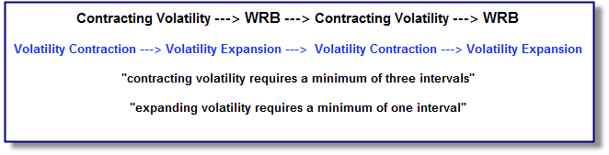

**http://thestrategylab.com/images/BlueBox.gif Charts of WRB (wide range bodies) and (wide range bars)**

We ask for you to take a closer look at the chart examples below to see the technical difference when comparing a candlestick chart to a bar chart via WRB Analysis on the exact same price action. In fact, any charts with a direct link posted below the chart implies the actual chart is larger than the chart displayed in this document and that you need to use the link to get the actual chart size **(download and print the chart)** because the chart image is too large for this document.

The below chart is a bar chart showing **13** WRBs based upon the WRB definition that a **W**ide **R**ange **Bar** is an interval that has a range (difference between High and Low) with a price area larger than the range of **each** of the prior **three intervals** (each interval individually compared to the WRB).

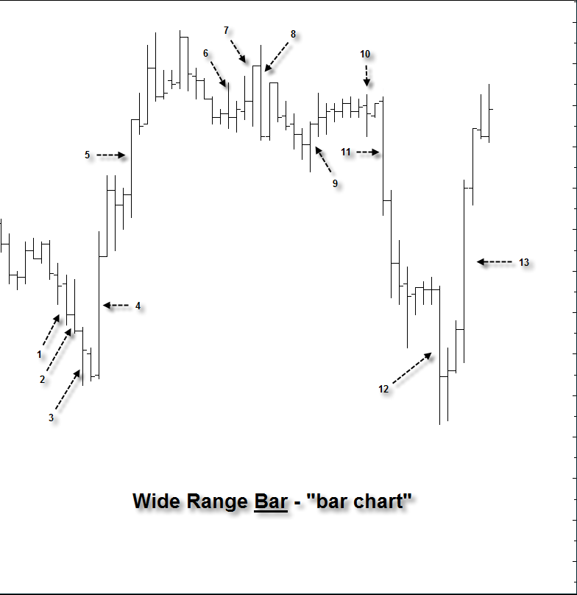

<http://www.thestrategylab.com/tsl/forum/download/file.php?id=980>

The below chart is a bar chart showing **14** WRBs based upon the WRB definition that a **W**ide **R**ange **Body** is an interval that has a body (difference between Open and Close) with a price area larger than the bodies of **each** of the prior **three intervals** (each interval individually compared to the WRB).

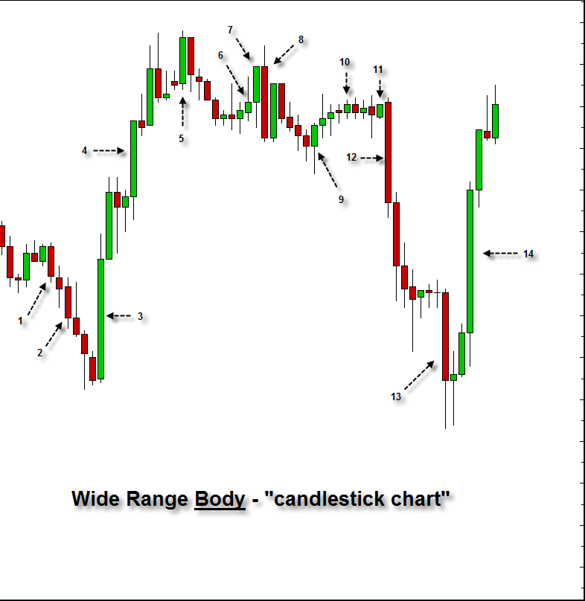

<http://www.thestrategylab.com/tsl/forum/download/file.php?id=981>

You can now see the subtle technical difference between a bar chart versus a candlestick chart via identifying WRBs…differences such as the number of WRBs and different intervals being identified as WRBs. However, not all WRBs are important. Thus, we only want to monitor the few WRBs that transform into **WRB Hidden Gaps** as shown in the next few charts.

**http://thestrategylab.com/images/BlueBox.gif WRB Hidden GAP**

The term **Hidden GAP** is a poor description and may confuse some traders.

First of all, the phrase Hidden GAP implies the price action within the range of the interval (difference between High and Low) on **bar charts** or range of the body (difference between Open and Close) on **candlestick charts** are typically viewed by most traders as only a volatility spike or expansion interval without realizing the price action involves trade actions of **key market participants**. Thus, there’s a wealth of **hidden information** in these expansion intervals that identifies important trade positions by key market participantswhich is the reason why I started using the phrase Hidden GAP. Simply, the WRB Hidden GAP represents key changes in supply/demand involving key market participants that allows us retail traders to visualize the key change in supply/demand via WRB Hidden GAPs as swing points, reaction points, trend reversals or strong continuation price actions. Just as important, more often than not, these key price areas have impact on the price action that occurs afterwards until price action traverses through the area.

The **visualization** of key market participants via WRB Hidden GAPs allows traders to improve risk management, improved trade management, improved position size management in comparison to participating in trades outside of these key changes in supply/demand price areas.

With that said, a **WRB Hidden GAP must first qualify as a WRB** prior to being transformed into a WRB Hidden GAP.

The Hidden GAP is determined (defined) by the price action of the single interval ***before*** the WRB and the price action of the single interval ***after*** the WRB. Simply, as shown in the next several charts, if you remove the WRB and there’s **no overlapping in prices** (not a single tick) between the interval ***before*** the WRB and the interval ***after*** the WRB…the WRB is transformed into a WRB Hidden GAP based upon the price action of the interval ***before*** the WRB and the interval ***after*** the WRB. Therefore, it’s the first interval **before and after** the WRB that will help determine the size of the Hidden GAP area for those WRBs that qualify as a WRB Hidden GAP.

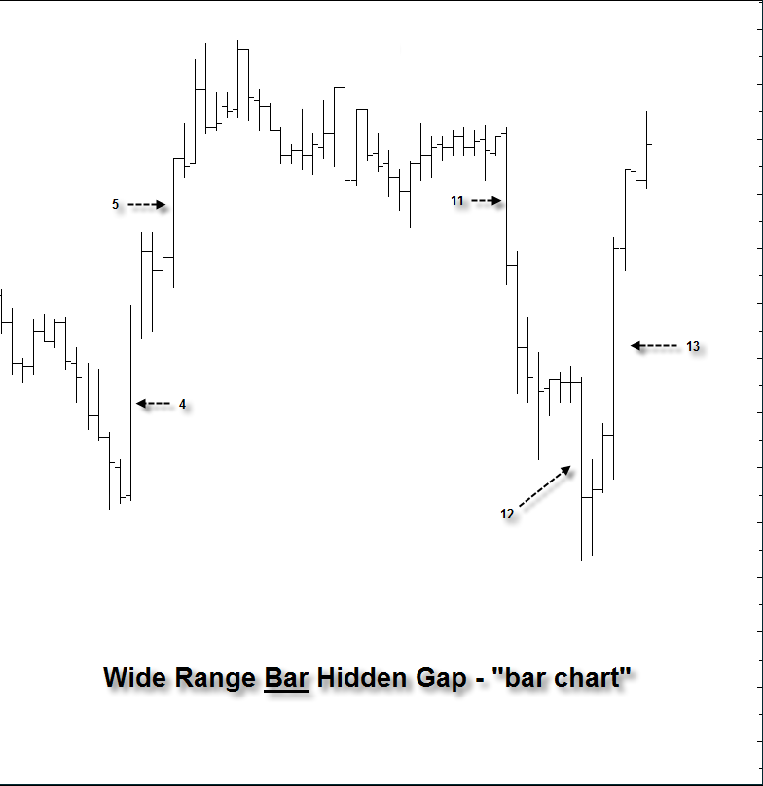

<http://www.thestrategylab.com/tsl/forum/download/file.php?id=982>

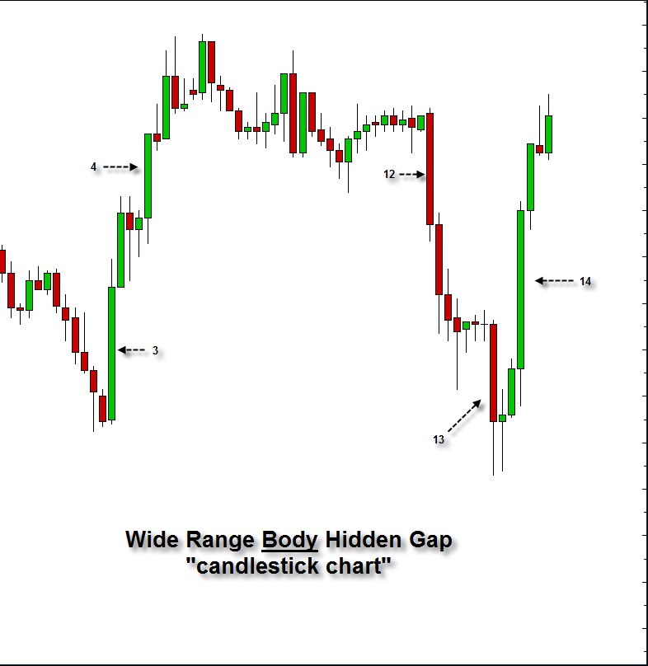

<http://www.thestrategylab.com/tsl/forum/download/file.php?id=983>

Now study the next chart very carefully. You’ll see that the WRB Hidden GAP intervals have been removed from the below bar chart and candlestick chart to show that the interval ***before and after*** the WRB do not have any overlapping price action in ticks. Simply, if the intervals **before** and **after** are overlapping any single tick in the price action, there's **no** key change in volatility or supply/demand because it would just be a WRB (not a WRB Hidden GAP) that represents indecisive market participants.

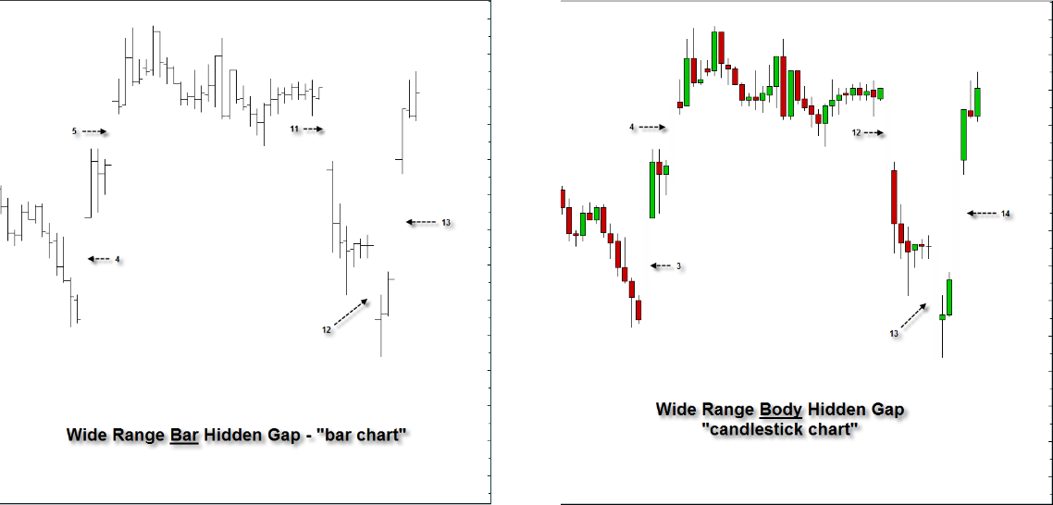

<http://www.thestrategylab.com/tsl/forum/download/file.php?id=984>

Further, the bar chart and candlestick chart are identical in identifying WRB Hidden Gaps. Simply, there are subtle differences on different types of charts when identifying WRBs. Yet, as stated, not all WRBs are important. In contrast, a WRB Hidden Gap is one of the most important price actions to identify key changes in supply/demand and key changes in volatility involving key market participants. In comparison, the most important price action to identify key changes in supply/demand and volatility are via WRB Zones that you’ll learn in tutorial chapter 2.

Also, most charting programs that allows coding can be setup to automatically identify WRBs or WRB Hidden Gaps.

  TradeStation

  ThinkorSwim

  Ninjatrader

  Multicharts

  Esignal

  Other charting programs

In fact, many free users and fee-base have coded WRBs and WRB Hidden Gaps to make identification of these key concepts easier even though TheStrategyLab itself **does not** use codes nor provide codes except to provide a thread at the forum for traders to share their codes. Therefore, if you’re a coder/programmer, please post your codes of tutorial chapters 1 and 2 with chart examples involving WRBs and WRB Hidden GAPs in the thread called **Formula Writing, Codes and Systems** **@** <http://www.thestrategylab.com/tsl/forum/viewforum.php?f=225>

**http://thestrategylab.com/images/BlueBox.gif WRB Hidden GAP (filled)**

The chart examples below have two charts within each image. The chart on the left shows a WRB Hidden GAP whereas the chart on the right has the exact same price action with the only difference is that the WRB Hidden GAP has been removed (erased) to reveal a Hidden GAP along with showing the definition of a price action that **fills the price area of a Hidden GAP**. Simply, the movement of the price action must have traversed through the body area of the interval (candlestick chart users), range area of the interval (bar chart users) or through the hidden gap area itself for traders that prefers to only use the actual hidden gap area for their WRB Analysis to represent **the fill**.

This is a very important concept for you to remember…price action filling in the price area of a WRB Hidden GAP via **traversing completely through** the price area because you’ll see this “fill” concept discussed again in tutorial chapter 2 involving WRB Zones S/R areas.

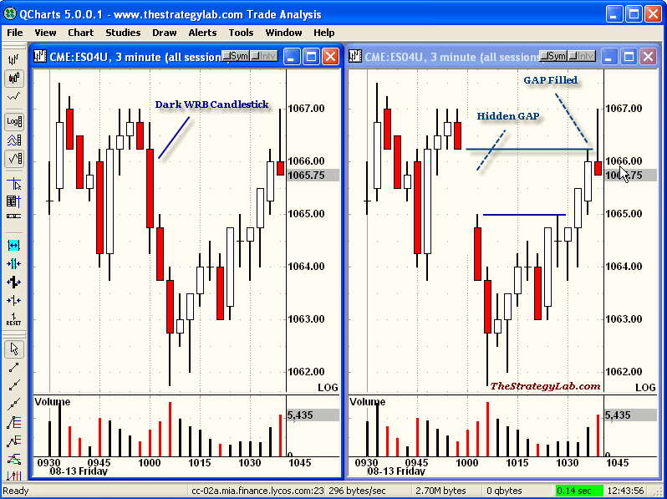

**Emini ES futures @** <http://www.thestrategylab.com/tsl/forum/download/file.php?id=638>

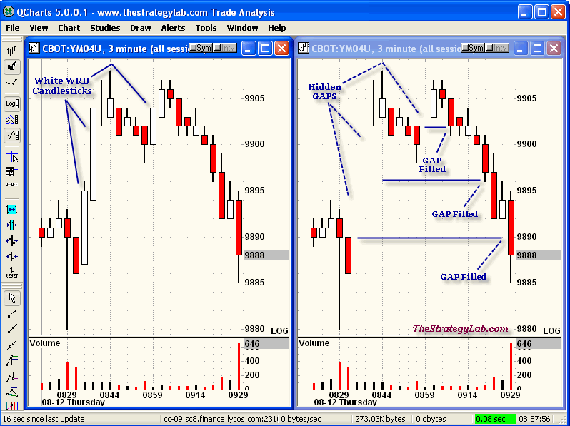  
**Emini YM futures @** <http://www.thestrategylab.com/tsl/forum/download/file.php?id=637>

**http://thestrategylab.com/images/BlueBox.gif Chart Summary of WRB and WRB Hidden GAP**

The chart below has each interval labeled with a letter to make it easier to understand.

  WRB intervals: d, e, i, j, n, p and v.

  WRB Hidden GAP intervals: i, j, n and p

Interval (i) is a WRB HG because interval (h) is not sharing a single tick with interval (j). In contrast, it’s ok for intervals (h) and (j) to share a tick with interval (i).

Interval (j) is a WRB HG because interval (i) is not sharing a single tick with interval (k). In contrast, it’s ok for intervals (i) and (k) to share a tick with interval (j).

Interval (n) is a WRB HG because interval (m) is not sharing a single tick with interval (0). In contrast, it’s ok for intervals (m) and (o) to share a tick with interval (n).

Interval (p) is a WRB HG because interval (o) is not sharing a single tick with interval (q). In contrast, it’s ok for intervals (o) and (q) to share a tick with interval (p).

  WRB Hidden GAP intervals filled in by the price action afterwards: i and j

  WRB Hidden GAP intervals still open (not filled): n and p

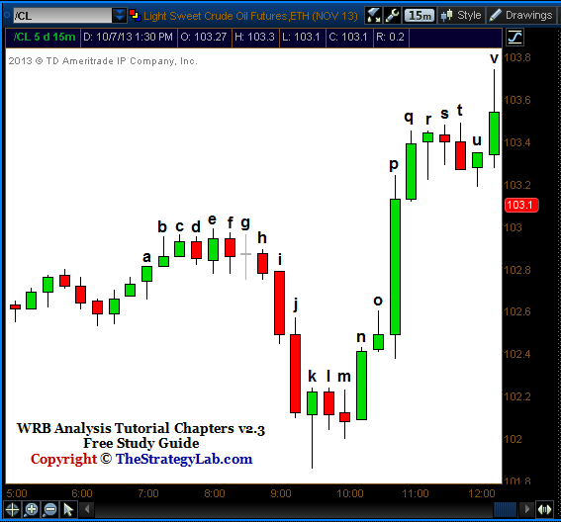

**Light Crude Oil CL futures @** <http://www.thestrategylab.com/tsl/forum/download/file.php?id=2847>

**http://thestrategylab.com/images/BlueBox.gif WRB Hidden GAP versus Normal Gap**

First of all, the definition of a Normal GAP is an empty price area between **yesterday’s** price action close and **today’s** price action open. The bigger the gap between two trading day sessions implies a key change in supply/demand at night regardless if your trading instrument was trading or not (.e.g. stocks) because markets are globally connected and key changes in other markets will have impact on the price action of your trading instrument even if your trading instrument is not trading.

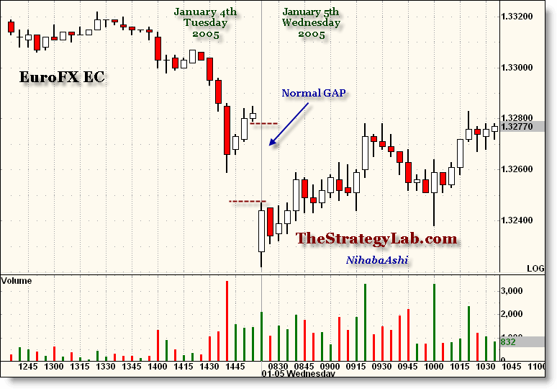

**EuroFX EC futures @** <http://www.thestrategylab.com/tsl/forum/download/file.php?id=639>

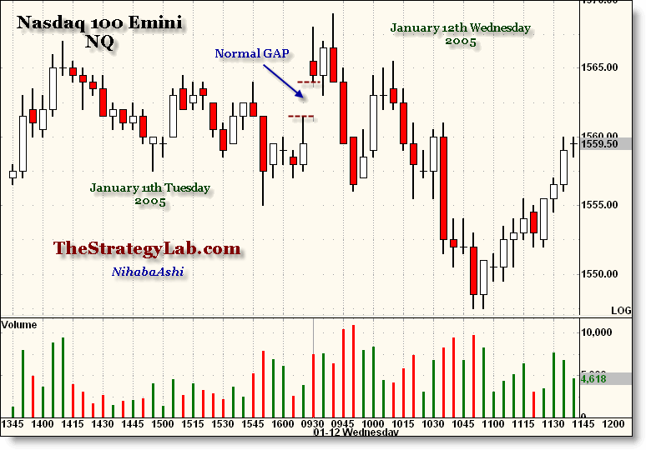

**Nasdaq NQ futures @** <http://www.thestrategylab.com/tsl/forum/download/file.php?id=640>

With that said, a WRB Hidden GAP has the exact same **price action behavior** as a Normal GAP when the normal gap is larger than each of the prior three intervals in yesterday’s trading session as shown in these chart examples.

This analogy of WRB Hidden GAPs with Normal GAPs starts to open the door involving WRB Analysis with many different types of trade strategies.

**http://thestrategylab.com/images/BlueBox.gif Uses for a WRB Hidden GAP**

 WRB Hidden GAPs shows where key market participants have open trade positions or exited trade and their actions has caused a key change in supply/demand. The change in supply/demand will involve a change from supply to demand (reversal) or change from demand to supply (reversal). It can also imply there’s a change from supply to more supply (continuation) or change from demand to more demand (continuation).

 All WRB Hidden GAPs (unfilled) can be used as profit targets when they occur ***prior*** to trade entries and used as profit targets that occurred ***after*** trade entries.

To be specific, if you take a position above or below a WRB Hidden GAP...more often than not the Hidden GAP will **behave like a magnet** and attract price action towards it even though the price action may not fill in the GAP.

 **Forex currency traders** that use volume analysis can use WRB Analysis (volatility analysis) to see the “real volume” in the price action that can not be seen via volume analysis alone due to the volume being only *measured as tick changes* because there is no central exchange (decentralized) like stocks and futures.

Therefore, WRB Analysis uses WRBs, WRB Hidden GAPs and Volatility Contraction to enable traders to know **when and where** the actions of smart money, institutional money and professional traders has occurred.

 WRB Hidden GAPs represents the most **current info** about key changes in supply and demand.

 WRB Hidden GAPs tells us we are no longer in chop and that it’s a breakout interval above or below the prior intervals. However, it does not tell us that the price action will continue in the same direction as the breakout because WRB Hidden GAPs all by themselves are **not** trade signals.

 WRB Hidden GAPs **not present** in the price action...the price action is most likely consolidating and/or in a low volatility trading range being traded by none important market participants.

Simply, it’s high risk trading when trading whenever there are **no** WRB Hidden GAPs or trading in price action that quickly retraces WRB Hidden GAPs. Therefore, the lack of WRB Hidden GAPs (unfilled) is telling you to stay on the sideline (no trading).

 WRB Hidden GAPs have the same price action characteristics of Normal GAPs. The parallel opens the doorway for application of many strategies (e.g. gap strategies, breakout strategies, s/r strategies, pivot strategies et cetera).

## **WRB** Analysis Tutorial Chapter 2

**http://thestrategylab.com/images/News4.gif** The following are the key concepts in tutorial chapter 2.

 Key Market Events (KME)

 First WRB Hidden GAP that appears at/after the key market event.

 Swing Points and Strong Continuation price actions identification

 WRB Zones

A quick summary of using the above, key market events (e.g. economic report or breaking news event) are often the catalyst (reason) that causes trends to change direction as in a reversal **or** extend the trend direction as in a strong continuation price action.

Learning the key concepts will allow you to identify key changes in supply/demand and volatility resulting in a stronger understanding of the price action you’re along with improving your trading performance.

http://www.thestrategylab.com/images/BlueSphere.gif **Key Market Events**

Floor traders, institutional traders, hedge funds et cetera that represent key market participants will use **key market events** (e.g. FED news, breaking news, economic report releases and geopolitical events) to determine when to open, add, close or reduce their trade positions. In fact, their reactions to key market events results in **key changes in supply/demand** along with these events being big pieces of the puzzle called **market context**. It’s the understanding of the market context, before the appearance of any trade signals, that’ll improve the performance of your trade signals from entry to exit. Further, you’re going to learn one particular way to identify these key changes in supply/demand via the transformation of a **WRB Hidden GAP into a WRB Zone**.

Something else to remember, the more hype by the financial networks, institutions, analysts, fund managers and other professional traders about a pending key market event for several days before the event…it will produce a bigger price reaction to the event and/or produce a bigger WRB Hidden GAP in comparison to key market events that are not hyped.

**Understanding the Price Action:** The key is that you must understand that you can trade with key market participants resulting as profits or trade against them in price areas that’s often just price noise resulting as losses. Therefore, your trade signals and profit target **reliability increases dramatically** if occurring within key price areas called **WRB Zones** where key participants are very likely to have opened, added, reduced or closed trade positions. Also, following the flow of key changes in supply/demand you’ll be able to adapt your trade strategies more easily along with minimizing drawdown periods.

Further, it doesn’t matter what’s said in the key market event and **don’t** try to use the information to predict price direction. The only thing you should be looking for is a **price reaction** (key change in supply/demand and volatility) to the key market event represented by the appearance of the **first** WRB Hidden GAP that you’re going to learn because a change in volatility creates trade opportunities along with being used to better manage trades after entry.

Also, **don’t** try to use the key market event to try to predict price direction (e.g. bad news will cause markets to decline) because it’s very common to see an unexpected price reaction to the key market event. Therefore, the only thing you should be looking for is a price reaction (key change in volatility) to the key market event represented by the appearance of the **first** WRB Hidden GAP **at/after** the key market event because a change in volatility creates trade opportunities.

In addition, we highly recommend you use a real-time news source and set it up to alert you to events by the **Federal Reserve (FED)**, **European Central Bank (ECB)**, **International Monetary Fund (IMF)** or any key words about current issues that have an impact on today’s financial markets (e.g. Eurozone).

Yet, if you can’t afford real-time news source, twitter real-time feeds are excellent resources because they can be used on computers, iPhone, iPad or android.

http://www.thestrategylab.com/images/MoreInfo.gif  TweetDeck **@** <http://www.tweetdeck.com/>

http://www.thestrategylab.com/images/MoreInfo.gif  StockTwits Tools **@** <http://stocktwits.com/mobile>

Also, if any of the above links are bad (not working because it has changed)…please use Google search to find the new link because this free study guide is only updated a few times per year.

Just in case you’re curious, many **professional traders** use twitter and stocktwits to communicate with each other about what’s impacting the price action as it is occurring in real-time within markets they’re trading. In addition, many real-time news sources like Bloomberg, Reuters, [Google News](http://news.google.com/), CNBC, MarketWatch, BBC News, International Business Times and many others tweet real-time market news.

With that said, there are **three types of key market events** that generate WRB Zones and we will first discuss the types of key market events **prior** to discussing the swing point and strong continuation price action definitions that transforms WRB Hidden GAPs into WRB Zones:

http://www.thestrategylab.com/images/MoreInfo1.gif  FED/ECB/IMF related key market event

http://www.thestrategylab.com/images/MoreInfo1.gif  Economic report key market event

http://www.thestrategylab.com/images/MoreInfo1.gif  Breaking news key market event

http://www.thestrategylab.com/images/BlueBox.gif **FED/ECB/IMF related Key Market Events**   
  
We are only interested in the **first** WRB Hidden GAP that occurs **at/after** the key market event because that **first** WRB Hidden GAP will qualify as a **WRB Zone** if the **first** WRB Hidden GAP is involved as a swing point **or** strong continuation price action via any of the price action definitions later detailed in tutorial chapter 2.

The following are **just a few** of the well known FED/ECB/IMF related key market events that will transform the **first** WRB Hidden GAP **at/after** the key market event into a WRB Zone. Also, the WRB Zone will remain active until the WRB Zone is filled by the price action that occurred afterwards.

 FOMC Announcement   
  
 FOMC Minutes   
  
 Philadelphia FED Survey

 Beige Book

 Richmond Fed Index  
  
 Current FED/ECB/IMF Leader speeches

 Former FED/ECB/IMF Leader speeches  
  
 ECB Announcement that's Europe's version of the U.S. FOMC Announcement   
  
 BOE Announcement that's England's version of the U.S. FOMC Announcement   
  
 BOC Announcement that's Canada's version of the U.S. FOMC Announcement

http://www.thestrategylab.com/images/BlueBox.gif **Economic Key Market Events**

We are only interested in the **first** WRB Hidden GAP that occurs **at/after** the key market event because that **first** WRB Hidden GAP will qualify as a **WRB Zone** if the **first** WRB Hidden GAP is involved as a swing point **or** strong continuation price action via any of the price action definitions later detailed in tutorial chapter 2.

You’ll need a good economic calendar and below are a few popular calendars:

http://www.thestrategylab.com/images/MoreInfo.gif  <http://fidweek.econoday.com>

http://www.thestrategylab.com/images/MoreInfo.gif  <http://www.forexfactory.com/calendar.php>

http://www.thestrategylab.com/images/MoreInfo.gif  <http://www.federalreserve.gov/calendar.htm>

http://www.thestrategylab.com/images/MoreInfo.gif  <http://www.ecb.int>

Here are **a few** of the well known economic key market events that tends to cause key changes supply/demand and key changes in volatility as identified via **first** WRB Hidden GAP if it qualifies as a WRB Zone.

 German ZEW Economic Sentiment

 French Flash Manufacturing PMI

 US Unemployment Claims

 EIA Petroleum Status (Crude Oil Inventories)

 US Existing Home Sales

http://www.thestrategylab.com/images/BlueBox.gif **Breaking News Key Market Events**

To exploit breaking news key market events you obviously will need to have access to continuous real-time news source via online or television that provide news 24hrs each day of news around the world. These worldwide news events behave like FED/ECB/IMF events or economic report event. Therefore, you'll be only interested in the **first** WRB Hidden GAP that's generated **at/after** the breaking news key market event and only if the **first** WRB Hidden GAP is **verified** by the swing point or strong continuation price action definitions.

Something else to remember, breaking news event that later gets revised or reported later as false...the market will often **retrace the price action** back to the **first** WRB Hidden GAP involving breaking news key market events if the news is found to be false, rumored or follow-up with another news event that makes the prior news event seem like it's been resolved.

Here are **a few** of the well known breaking news key market events that tends to cause key changes supply/demand and key changes in volatility as identified via **first** WRB Hidden GAP if it qualifies as a WRB Zone.

 European Debt Crisis News

 Geo-Political Crisis

 Natural Disasters (e.g. earthquakes)

 Corporate Earnings Announcements

 Wars, Conflicts or Violence that captures the world’s attention

http://www.thestrategylab.com/images/BlueSphere.gif **First WRB Hidden GAPs**

As a reminder, WRB Analysis (WRBs or WRB Hidden GAPs) are **not** trade signals. Instead, they are used to identify key changes in supply/demand via transformation into a WRB Zone so that you can exploit the price action via **your** trade methods if/when the price action returns to the key price area (WRB Zone).

Yet, if you don’t have a trade signal of your own to merge with WRB Analysis…you can use our **free** trade strategy called **Fading Volatility Breakouts @** <http://www.thestrategylab.com/tsl/forum/viewforum.php?f=89> after you’ve learned basic tutorial chapters 1 and 2.

Further, to best explain our phrase the “**first** WRB Hidden GAP” you’ll see on my charts and on the charts of many users that are learning/applying WRB Analysis within their trade methods via tutorial chapter 2, is that you should **start counting** the number of WRB Hidden GAPs **(left to right)** that appears **at/after** the key market event so that we can give them a number identity (e.g. first, second, third and so on) to make it easier to understand each other’s price action discussions.

That simple number counting of the WRB Hidden GAPs will keep you focus on the most important price action via what’s occurring **at/after** the key market event instead of what’s occurring *before* the event involving the discussion here in tutorial chapter 2.

Here are a few **basic rules** to remember about **first** WRB Hidden GAPs that occurs **at/after** key market events prior to learning the swing point and strong continuation price action definitions:

 The **first** WRB Hidden GAP is the only WRB Hidden GAP **at/after** a key market event that can be used to determine if there’s a key change in supply/demand.

 The **first** WRB Hidden GAP **at/after** a key market event must be a breakout interval of the *range of each of its most recent three intervals* that occurred before the **first** WRB Hidden GAP.

 The **first** WRB Hidden GAP **at/after** a key market event can only qualify as a **WRB Zone** if it results as a swing point or strong continuation price action definition as discussed here in tutorial chapter 2. Yet, if the **first** WRB Hidden GAP does **not** qualify as a WRB Zone via tutorial chapter 2…it still may be useful (e.g. profit target if your Short position is above it or Long position below it).

 Do not traverse (search) the price action after the **first** WRB Hidden GAP for another WRB Hidden GAP to qualify as a WRB Zone if the **first** WRB Hidden GAP failed to qualify as a WRB Zone. Simply, if the **first** WRB Hidden GAP doesn't qualify as a WRB Zone...you must wait for the next key market event to start over again to see if the price action associated with the new key market event will produce a **first** WRB Hidden GAP that can qualify as a WRB Zone.

http://www.thestrategylab.com/images/BlueSphere.gif **Swing Point and Strong Continuation Price Action Definitions**

Swing point price action implies the trend has changed via a reversal in the price action **or** the price action has counter-thrust back (retraced) against the trend. If that counter-thrust (retracement) price movement behavior **fills in** the price area of any **prior** WRB Hidden GAP that was unfilled or **fills in** the price area of any prior consecutive same direction intervals…the price action that change the trend is called a swing point. Just as important, the swing point price action contains a key market event that produces a WRB Hidden GAP that qualified as a WRB Zone as discussed later here in tutorial chapter 2 **or** qualified as a swing point via your own personal definitions of a swing point.

Definition of Fill In (filled): The movement of the price action must have retraced and then traversed through the **body** area (candlestick chart users) of the WRB Hidden GAP interval, through the **range** area (bar chart users) of the WRB Hidden GAP interval, through the **hidden gap** area itself for traders that prefers to only use the actual **hidden gap** area or through the WRB Zone **S/R area** to represent **the fill**.

Strong Continuation price action is basically a **trend** involving multiple WRB Hidden GAPs in the same price direction and most of these WRB Hidden GAPs are unfilled along with at least one of the unfilled WRB Hidden GAPs qualifying as a WRB Zone involved with a recent key market event **or** qualified as a strong continuation (trend) via your own personal definitions.

**Note:** Identifying swing point price actions and strong continuation price actions that qualify as WRB Zones without using the help of key market events is only taught to traders that purchase any of the WRB Analysis Advance Tutorial Chapters 4 – 12. The advance tutorial chapters 4 – 12 are useful for traders that don’t have the time to follow key market events even though we highly recommend to our advance tutorial chapters clients to master tutorial chapter 2 so that they can know what really moves the markets they’re trading.

As a reminder, there are many different types of swing points and many different types of strong continuation price actions. We only talk about a few of them in this free study guide although other types of price actions were discussed in older versions of the free study guide. Further, if you prefer to use your own price action definitions of swing points or strong continuation price actions…you should still ask us for help in showing you how to identify key changes in supply/demand involving your own price action definitions if you’re having problems with the identification.

In addition, if you’re having problems in understanding tutorial chapter 2, you can get help in understanding tutorial chapter 2 and 3 via posting your questions at the TSL Support forum **and/or** in the ##TheStrategyLab chat room. The forum and chat room are **free resources** for you to use. More information about these additional **free resources @** <http://www.thestrategylab.com/tsl/forum/viewforum.php?f=90>

http://www.thestrategylab.com/images/BlueBox.gif **Swing Point Definitions** (two different types)

We’re now discuss two different types of swing point price action definitions even though there are many other types of swing point price actions not discussed here that involve key market events and other types of swing point price actions that do not involve key market events that are only shared with fee-base clients of the [Advance Tutorial Chapters 4 – 12](http://www.thestrategylab.com/WRBAnalysisTutorials.htm) or [Volatility Trading Report (VTR)](http://www.thestrategylab.com/VolatilityTrading.htm).

**Swing Point #1 -** The key concept for swing point price action definition #1 is when the key market event occurs, it produces a WRB Hidden GAP in the **same interval** as the key market event. Therefore, swing point price action definition #1 is defined as a *change of price direction* (swing point) that involves a key market event that produces a **first** WRB Hidden GAP in the **same interval** as the key market event.

One of the following must occur in the price action **after** the key market event:

 The price action movement after the **first** WRB Hidden GAP continues in the same price direction as the **first** WRB Hidden GAP…continuing and then **fills in** the price action of any **prior** WRB Hidden GAP that was unfilled…the *change in price direction* must occur **prior** to the formation of the next swing point (any type of swing point).

 The price action movement after the **first** WRB Hidden GAP continues in the same price direction as the **first** WRB Hidden GAP…continuing and then **fills in** the **range** (highest high to lowest low) of any **prior** three consecutive same direction intervals…the *change in price direction* must occur **prior** to the formation of the next swing point (any type of swing point).

Note: The **prior** WRB Hidden GAP (unfilled) **or** the **prior** three consecutive same direction intervals must have occurred **before** the key market event interval (**first** WRB Hidden GAP).

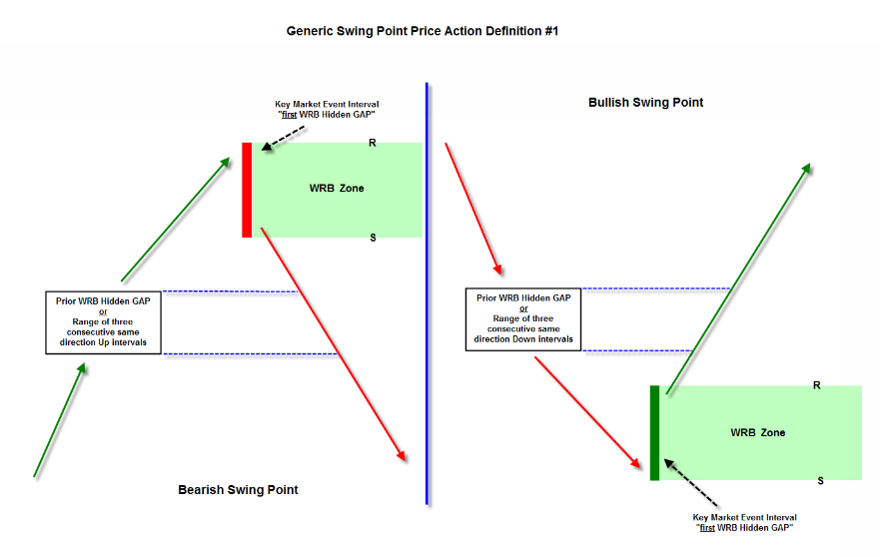

<http://www.thestrategylab.com/tsl/forum/download/file.php?id=3082>

Bullish Swing Point - The key market event interval (**first** WRB Hidden GAP) must have its price close **below** the close price of any **prior** Down WRB Hidden GAP even though it may not be the same **prior** Down WRB Hidden GAP that gets filled by the price action **after** the key market event interval (**first** WRB Hidden GAP) **or** the key market event interval (**first** WRB Hidden GAP) must have its price close **below** the **range** (highest high to lowest low) of any **prior** three consecutive declining same direction intervals.

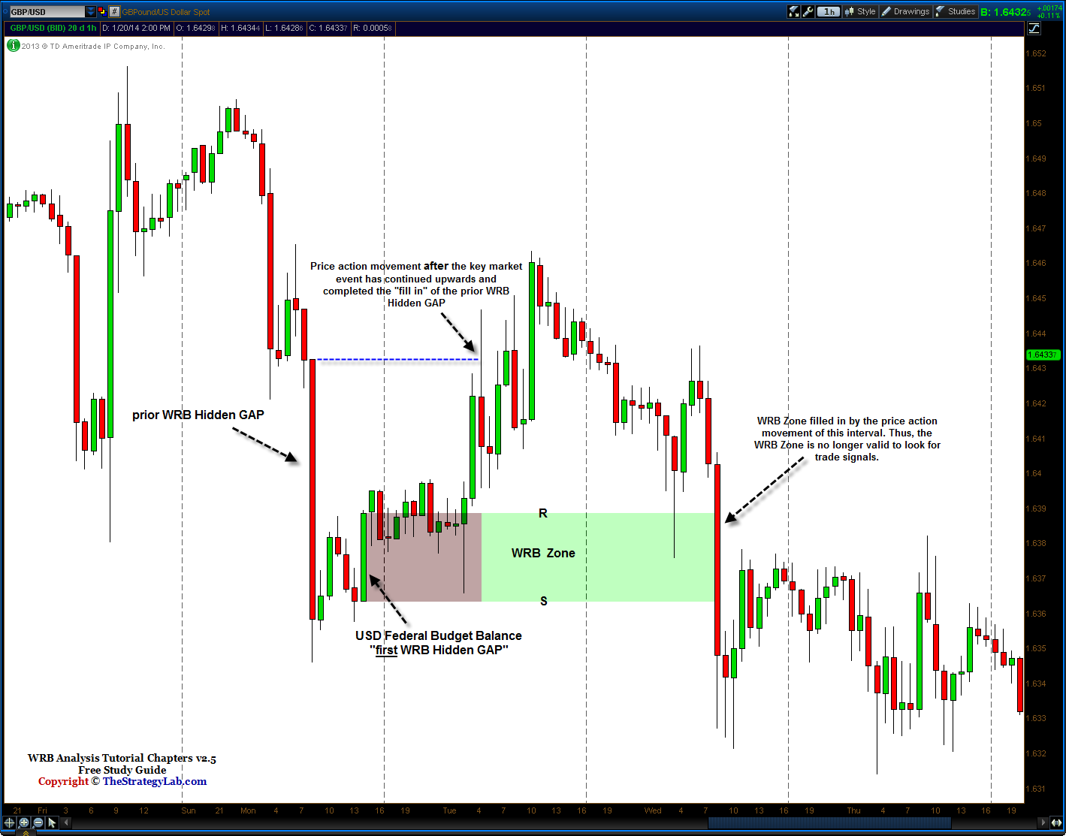

**Forex USD/JPY currency @** <http://www.thestrategylab.com/tsl/forum/download/file.php?id=3081>

Bearish Swing Point - The key market event interval (**first** WRB Hidden GAP) must have its price close **above** the close price of the **prior** Up WRB Hidden GAP GAP even though it may not be the same **prior** Up WRB Hidden GAP that gets filled by the price action **after** the key market event interval (**first** WRB Hidden GAP) **or** the key market event interval (**first** WRB Hidden GAP) must have its price close **above** the **range** (highest high to lowest low) of any **prior** three consecutive rising same direction intervals.

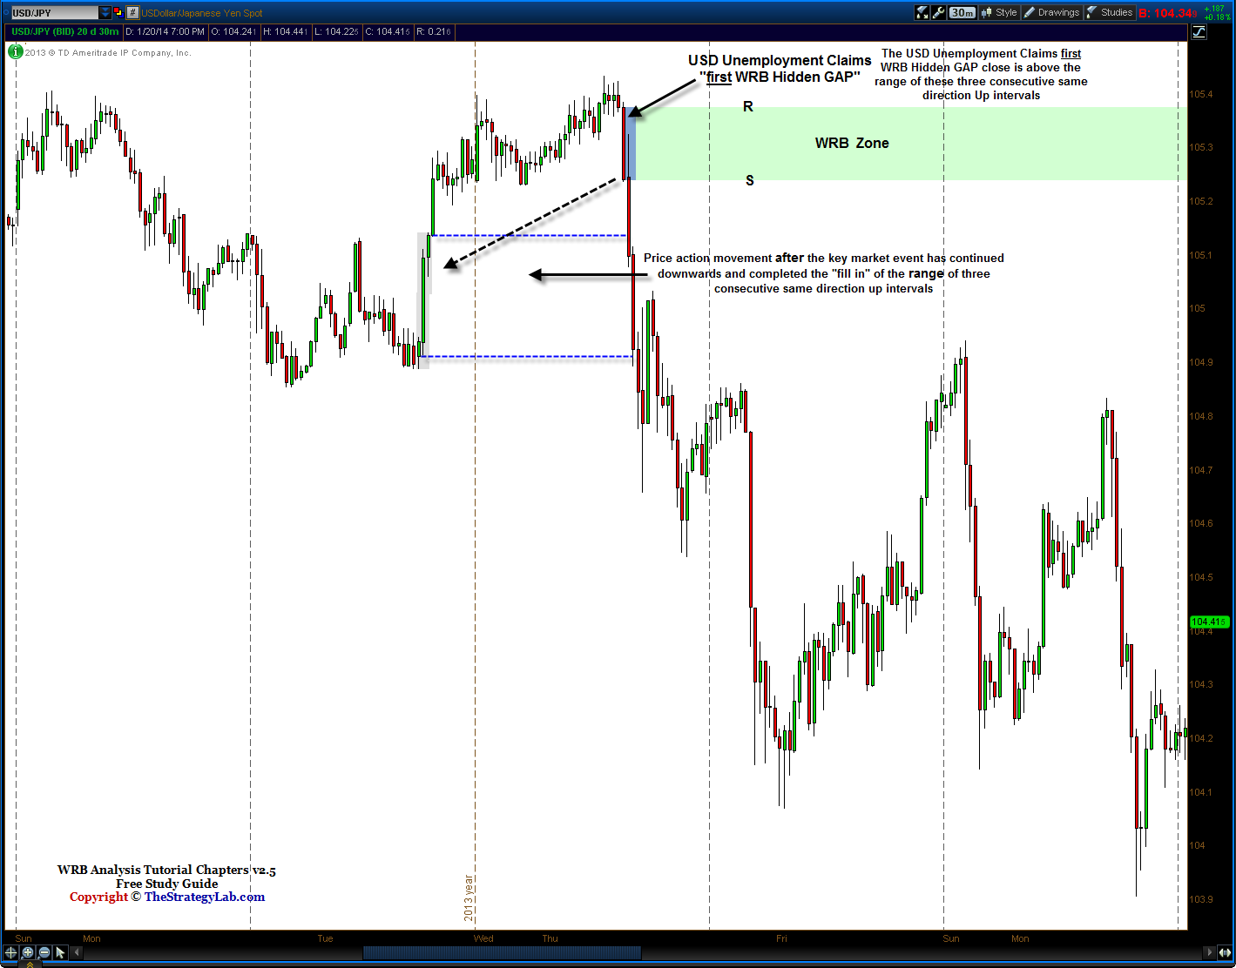

**Forex USD/JPY currency @** <http://www.thestrategylab.com/tsl/forum/download/file.php?id=3085>

**Swing Point #2 –** The key concept for swing point price action definition #2 is that the key market event interval is **not** a WRB Hidden GAP and it must occur amongst contracting volatility intervals that occurred **before** the **first** WRB Hidden GAP interval. Also, the first WRB Hidden GAP interval that occurred after the key market event interval...that first WRB Hidden GAP interval must be larger than the contracting volatility intervals. Simply, the initial price reaction to the key market event is as if the key market event was not important to the price action. In contrast, it’s very common for key market participants to digest (analyze) the information from the key market event resulting in contracting volatility or indecision **prior** to reacting and then producing the **first** WRB Hidden GAP (volatility expansion) interval.

Key Market Event Intervals – These intervals are the **volatility contraction** intervals because they are occurring **before** the **first** WRB Hidden GAP (volatility expansion). Also, each of these intervals can be either a Close = Open, Close > Open or Open > Close. Yet, one of the intervals in the volatility contraction must have occurred **at** the release time of the key market event.

-------------------------------------------------

Bullish Swing Point - Price action was declining and then reversed direction (swing point involving a key market event) and then price rises back upwards to produce three consecutive higher closing intervals and each interval is (Close > Open) **prior** to the next swing point. The **first** WRB Hidden GAP is one of the three consecutive higher closing intervals and each interval is (Close > Open).

Further, the three consecutive higher closing intervals involving the **first** WRB Hidden GAP, they must occur **after** the key market event. Also, the **first** WRB Hidden GAP must have shared at least one tick with the range of the volatility contraction to prevent looking like a continuation price action instead of as a swing point.

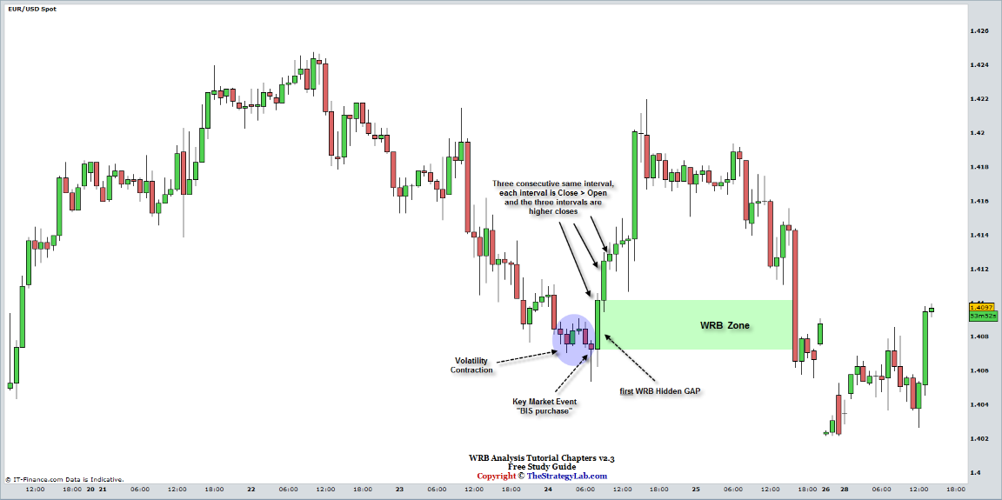

**Forex EUR/USD currency @** <http://www.thestrategylab.com/tsl/forum/download/file.php?id=1054>

Bearish Swing Point - Price action was rising and then reversed direction (swing point involving a key market event) and then price declined back downwards to produced three consecutive lower closing intervals and each interval is (Open > Close) **prior** to the next swing point. The **first** WRB Hidden GAP is one of the three consecutive lower closing intervals and each interval is (Open > Close).

Further, the three consecutive lower closing intervals involving the **first** WRB Hidden GAP, they must occur **after** the key market event. Also, the **first** WRB Hidden GAP must have shared at least one tick with the range of the volatility contraction to prevent looking like a continuation price action instead of as a swing point.

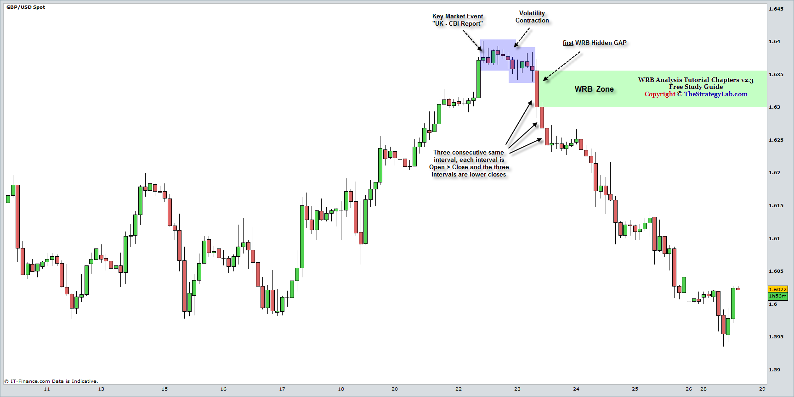

**Forex GBP/USD currency @** <http://www.thestrategylab.com/tsl/forum/download/file.php?id=1053>

http://www.thestrategylab.com/images/BlueBox.gif **Strong Continuation Price Action Definition** (two different types) 

We’re going to now discuss two different types of strong continuation price action definitions even though there are many other types of strong continuation price actions not discussed here that involve key market events and other types of strong continuation price actions that do not involve key market events that are only shared with fee-base clients of the [Advance Tutorial Chapters 4 – 12](http://www.thestrategylab.com/WRBAnalysisTutorials.htm) or [Volatility Trading Report (VTR)](http://www.thestrategylab.com/VolatilityTrading.htm).

**Strong Continuation #1 -** Defined as producing two or more same color WRB Hidden GAPs (they don't need to occur consecutive as in back to back) in which the **first** WRB Hidden GAP is the **breakout interval** above the most recent **reaction high** (bullish continuation) or below the most recent **reaction low** (bearish continuation) price action and the other WRB Hidden GAP interval must have occurred **after** the **first** WRB Hidden GAP interval before the next swing point.

 The key market event can occur before the **first** WRB Hidden GAP but it must occur between the reaction high/low and the **first** WRB Hidden GAP. Also, if it does occur before the **first** WRB Hidden GAP, the key market event interval must **not** be a WRB Hidden GAP interval.

 The key market event must **never occur after** the **first** WRB Hidden GAP breakout interval.

Reaction High - Price action had a minimum of two consecutive white intervals (Close > Open) with higher closes before the reaction high and then price decline after the reaction high to produce a minimum of two consecutive dark intervals (Open > Close) with lower closes.

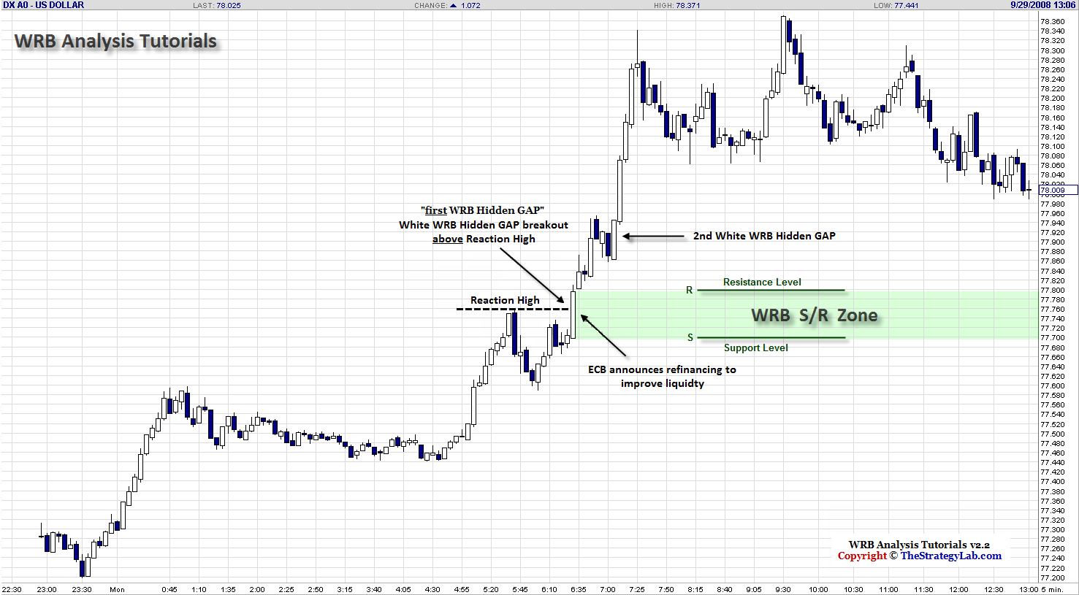

**U.S. Dollar currency @** <http://www.thestrategylab.com/tsl/forum/download/file.php?id=1063>

Reaction Low - Price action had a minimum of two consecutive dark intervals (Open > Close) with lower closes before the reaction low and then price rising after the reaction low to produce a minimum of two consecutive white intervals (Close > Open) with higher closes.

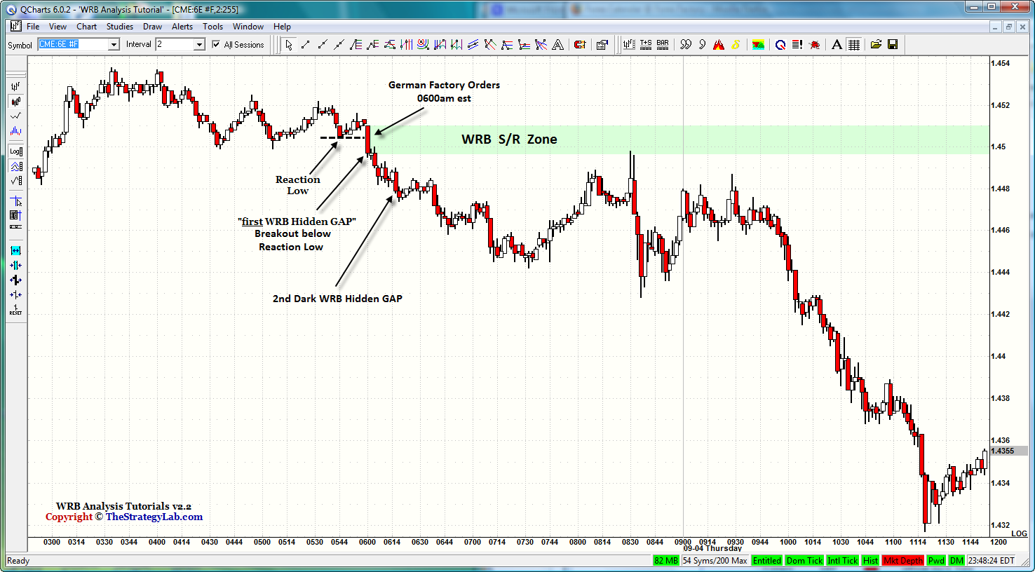

**EuroFX 6E futures @** <http://www.thestrategylab.com/tsl/forum/download/file.php?id=1062>

**Strong Continuation #2 -** This is your first introduction into the words **v2**, contracting volatility and **v1**. The letter **V** represents a special type of WRB Hidden GAP that’s a volatility spike (expanding volatility) as a **breakout** of the **prior** contracting volatility (minimum of three intervals). Simply, a v1 WRB Hidden GAP and v2 WRB Hidden GAP are volatility breakouts of the most recent volatility contraction in the following price action sequence. Also, if you’re confused or curious about why we label the price action sequence as **v2 ---> v1** instead of **v1 ---> v2**…there’s an explanation at the TSL Support Forum @ <http://www.thestrategylab.com/tsl/forum/viewtopic.php?f=61&t=1195>

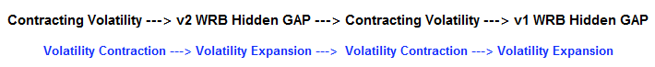

The above image is a very strict objective rule base price action. In contrast, we’re going to use rules a little different than the above strict rules but more detailed via stating the following…

 Only **one** of the WRB's (v1 or v2) is required to be a WRB Hidden GAP. Thus, both can be a WRB Hidden GAP or just one of them.

 Both v2 and v1 must be a **volatility breakout** above/below their prior contracting volatility even if only the v2 or v1 qualifies as a WRB Hidden GAP.

Therefore, v2 WRB only needs to be a breakout of its prior three intervals. In contrast, v1 WRB must be a breakout of **all** intervals between v2 and v1. For example, if there are ten intervals between v2 and v1...that v1 must be a breakout of **all** ten intervals that represent volatility contraction.

 The contracting volatility (minimum of three intervals) **between** v2 and v1, does not retrace (fill in the range) of the v2 WRB **and** its prior contracting volatility three intervals. Yet, if you prefer to use the original strict rule (as shown in the above image) that requires both v2 and v1 to be WRB Hidden GAPs…that’s OK.

 The contracting volatility (minimum of three intervals) **between** v2 and v1 intervals does **not** contain WRB’s that have bodies greater (larger) than the bodies of v2 or v1 intervals.

 The v2 WRB and v1 WRB intervals are the same color (same direction).

Bearish Continuation - Price action was declining (it contained a minimum of two dark lines with lower closes) before and above the close of the v2 Dark WRB…then followed by contracting volatility that traverses into a v1 Dark WRB (volatility spike) in which the price action continues declining (it contained a minimum of two dark lines with lower closes) after and below the close of the v1 Dark WRB prior to the next swing point.

The **v1 WRB** must occur **at/after** the key market event. However, if using the **v2 WRB** as the WRB Zone…it must occur **at/after** the key market event.

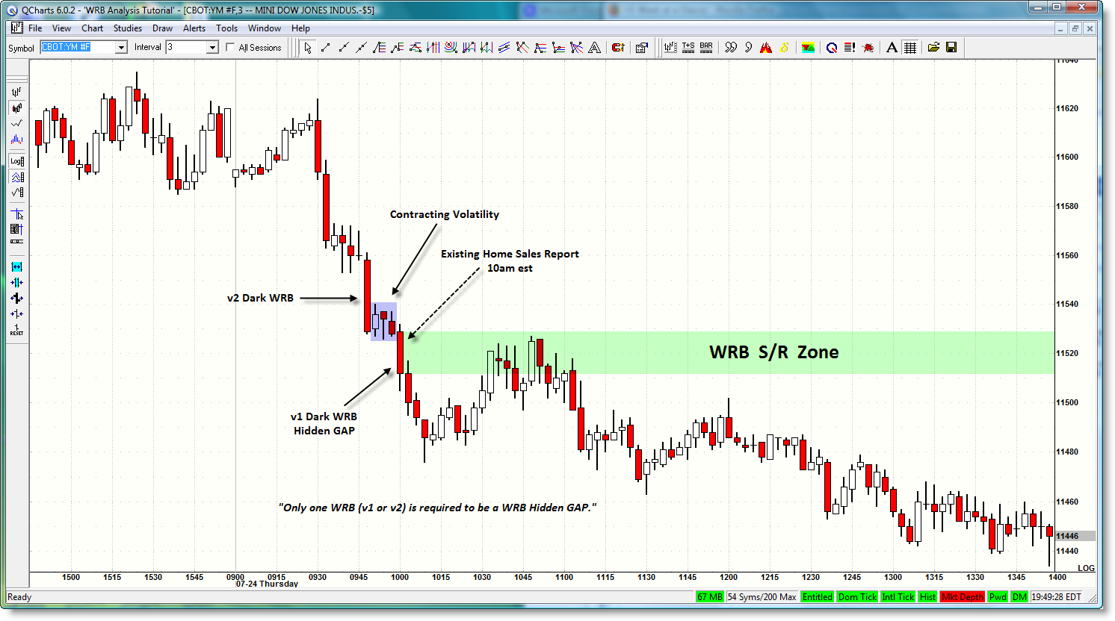

**Emini YM futures @** <http://www.thestrategylab.com/tsl/forum/download/file.php?id=626>

Bullish Continuation - Price action was rising (it contained a minimum of two white lines with higher closes) before and below the close of the v2 White WRB…then followed by contracting volatility that traverses into a v1 White WRB (volatility spike) in which the price action continues rising (it contained a minimum of two white lines with higher closes) after and above the close of the v1 White WRB prior to the next swing point.

The **v1 WRB** must occur **at/after** the key market event. However, if using the **v2 WRB** as the WRB Zone…it must occur **at/after** the key market event.

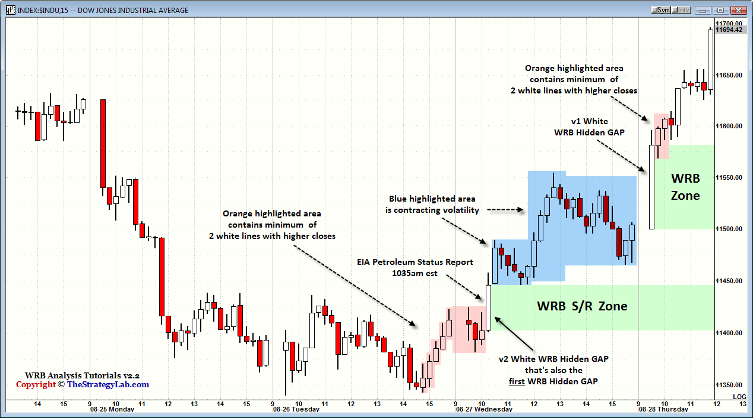

**Dow Jones Industrial Average Index @** <http://www.thestrategylab.com/tsl/forum/download/file.php?id=1340>

Also, it's common to see the price action correlate with more than one of the above strong continuation price action definitions. Yet, that does not imply that all the strong continuation price action definitions must be qualified because you only need **one of the above definitions** to qualify a **first** WRB Hidden GAP as a WRB Zone.

Once again, if you don't like our definitions of a swing point or strong continuation price action or they seem too confusing...**use your own definitions** of a swing point and strong continuation price actions that are more suitable for your trading style instead of trying to memorize our definitions. Our price action definitions are provided for those that do not know the difference between a swing point and strong continuation price action or for those that need a defined “price action” rule base explanation to remove as much subjectivity as possible from such type of price actions.

Further, if you’re going to use your own personal price action definitions of a swing point or strong continuation price action…write your price action definitions within any of your questions or “demonstration of knowledge” (DOK) message posts to prevent any misunderstanding.

http://www.thestrategylab.com/images/BlueSphere.gif **Key Change in Supply/Demand Price Area: Hidden GAP versus Body or Bar**

It’s a **personal choice** what price area you should use of the WRB Hidden GAP as a WRB Zone after identifying which WRB Hidden GAPs qualifies as a WRB Zone.

**W**ide **R**ange **Body** gives two options as a WRB Zone. The price area between the nearest tick of the single interval that’s ***before*** the WRB and the single interval ***after*** the WRB (the hidden gap) is one option or the price area between the Open and Close (the body) is the other option. Yet, it’s more common to see candlestick chart users using the body of the WRB (as shown in the chart on the right) instead of the actual hidden gap area as the WRB Zone.

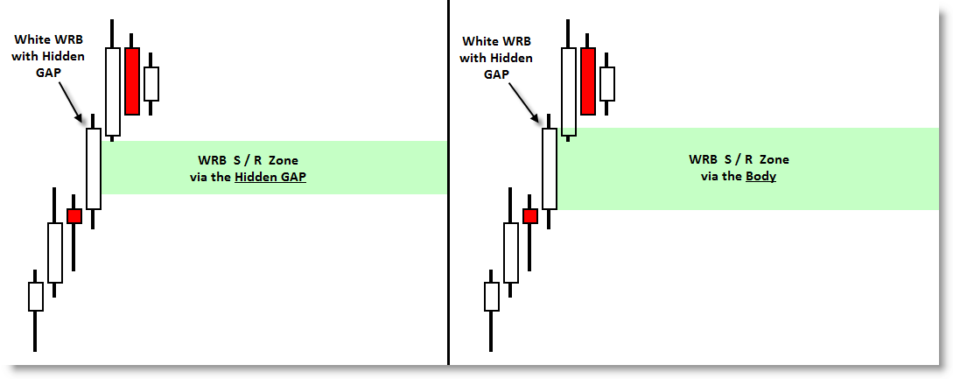

<http://www.thestrategylab.com/tsl/forum/download/file.php?id=636>

**W**ide **R**ange **Bar** gives two options as a WRB Zone. The price area between the nearest tick of the single interval that’s ***before*** the WRB and the single interval ***after*** the WRB (the hidden gap) is one option or the price area between the High and Low (the range) is the other option. Yet, it’s more common to see bar chart users using the entire range of the WRB (as shown in the chart on the right) instead of the actual hidden gap area as the WRB Zone.

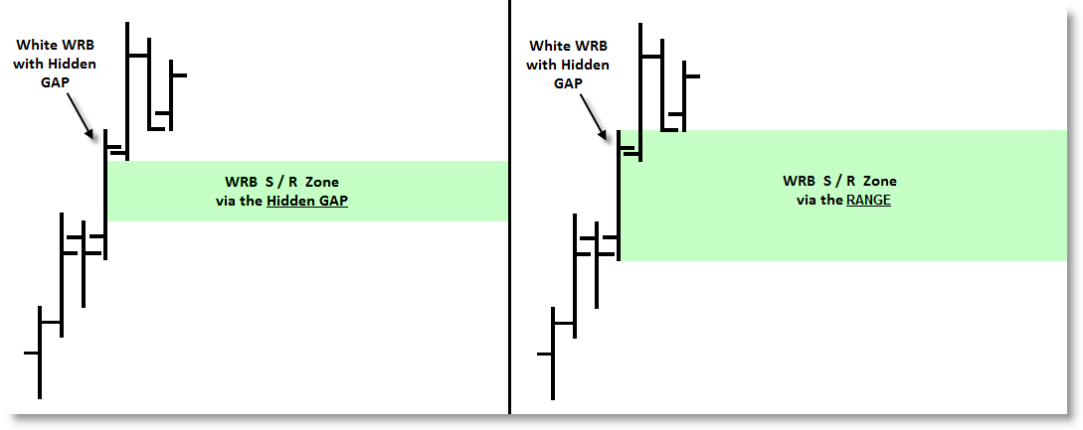

<http://www.thestrategylab.com/tsl/forum/download/file.php?id=985>

Further, after deciding which to price area to use as a WRB Zone, you must be consistent in using the same price area…hidden gap versus body for candlestick chart users or hidden gap versus range for bar chart users to keep subjectivity from developing in your trading from one trading day to the next trading day.

http://www.thestrategylab.com/images/BlueSphere.gif **Dynamic S/R Area of the WRB Zone**

WRB Zones and traditional s/r levels have similarities and differences that can confuse traders that use WRB Zones when they first begin learning about the zones. For example, it’s critically important that you understand a WRB Zone above current price is **not** a resistance zone and that a WRB Zone below current price is **not** a support zone. In contrast, if/when price **enters** a WRB Zone, the WRB Zone will then **transform** into high value s/r levels with the **R** as the upper level (resistance) of the zone and the **S** as the lower level (support) of the **same zone.** Therefore, it does not matter if price was rising or declining when it entered a WRB Zone…the top level of the zone is always the **R** (resistance) and the bottom level is always the **S** (support) whenever price enters the WRB Zone.

This dynamic change (transformation) of a WRB Zone into high value s/r levels remains until the price action **exits** the WRB Zone. Simply, the high value s/r levels transforms back into a WRB Zone when price is no longer inside the WRB Zone. Yet, the name support/resistance isn’t important because you can refer to them as upper/lower price areas of a WRB Zone if you prefer such.

Chart Info – EuroFX 6E price action is below the key market event WRB Zone*.* Thus, most traders using traditional support/resistance levels will assume that the WRB Zone above the price would be a **resistance zone**. In contrast via WRB Analysis, that WRB Zone is just a key price area to look for trade opportunities...Long (price action continuation) or Short (price action reversal) if/when price action returns to the WRB Zone. The WRB Zone can also be used as a profit target if you had taken a Long position below the WRB Zone.

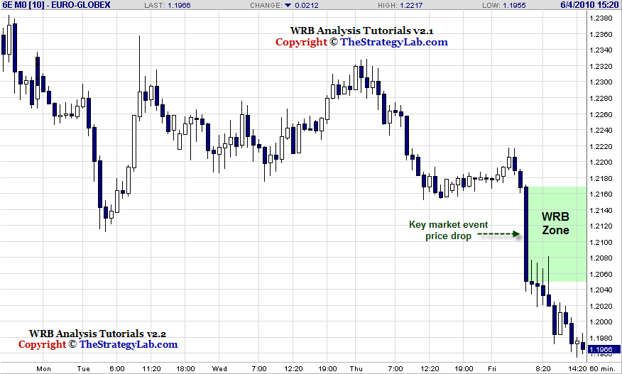

**EuroFX 6Efutures @** <http://www.thestrategylab.com/tsl/forum/download/file.php?id=963>

Chart Info – Continuing from the above chart, EuroFX 6E futures price action has now entered the WRB Zone, transforming the WRB Zone into high value **S/R Levels**.

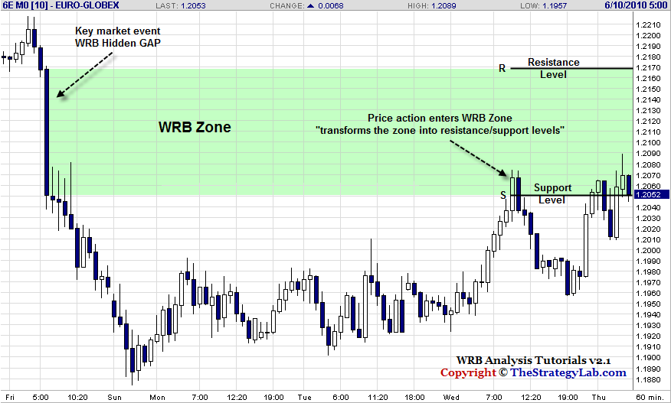

**EuroFX 6Efutures @** <http://www.thestrategylab.com/tsl/forum/download/file.php?id=964>

This transformation of a WRB Zone into high value **S/R Levels** is very important in enhancing your awareness of changes in supply/demand and designing your own trade strategies via the foundation given to you via the WRB Analysis Tutorials.

In addition, you must remember that a WRB Zone does not imply that the price action will reverse when price enters the zone. In contrast, when price enters a WRB Zone…you should be looking for **continuation signals** and **reversal signals** via whatever trade strategies you’re using.

Further, if you prefer taking trades outside of WRB Zones…you can still use the **WRB Zones for trade management** (e.g. stop/loss protection, profitable trail stops and profit targets).

http://www.thestrategylab.com/images/BlueSphere.gif **Life Span of a Key Market Event WRB Zone**

It’s very simple. **WRB Zones (unfilled)** are valid for use until the price action has traversed through its **S/R areas** regardless to the type of key market event and regardless to the type of swing point or strong continuation price action. Traversing through the S/R area implies the price action movement has shared a tick with the S area and shared a tick with the R area of the WRB Zone to qualify as traversing through the WRB Zone…filling in the WRB Zone.

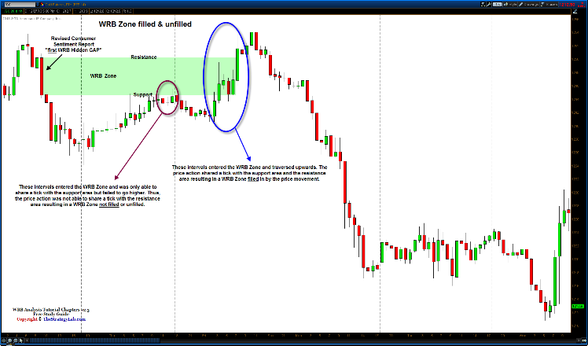

**Gold GC futures @** <http://www.thestrategylab.com/tsl/forum/download/file.php?id=3089>

You should use WRB Zones (unfilled) to look for trade signals if/when price action returns to the WRB Zone. Another use of WRB Zones, they can be used for trade management (e.g. initial stop/loss placement, profitable trail stop and profit targets) via their S/R areas as discussed here in the free study guide within the section called **Trade Management and Trade Entry**.

Yet, some traders will continue using a **filled** key market event WRB Zone until the next key market event WRB Zone because the key market event is **critically important** to their trading instrument whereas the same key market event is not important to another trader that trades a different trading instrument.

For example, the EIA Petroleum Status (Crude Oil Inventories) key market event is important to Light Crude Oil CL futures traders but is not important to traders of Treasury ZB futures. That’s the reason why this new free study guide version no longer ranks specific key market events as critical or miscellaneos because of the fact that so many users of the study guide are trading different trading instruments in comparison to each other.

Also, for those that prefer to rank their key market events, you can easily determine which key market events are critical or miscellaneous via reviewing a few months (minimum) of price history involving the price reaction to a specific key market event that resulted as either a swing point price action, strong continuation price action or big WRB Hidden GAP. You can then catagorize them as strong/weak, high impact/low impact, critical/misellaneous or via any terminology you want.

http://www.thestrategylab.com/images/BlueSphere.gif **Hindsight Charts versus Real Trading Conditions identification of WRB Hidden GAPs and WRB Zones**

There are many hindsight charts posted at the discussion forum in the WRB Analysis Tutorials Question & Answer threads. Yet, just because you can easily identify WRBs, WRB Hidden GAPs and WRB Zones on hindsight charts doesn't imply it’s just as easy when trading with real money or simulator in real-time market conditions.

Therefore, here's a simple trick to help you traverse from hindsight chart expert to **real trading application**.

First of all, you must **demonstrate your knowledge** (DOK) in the Questions & Answers thread via the detailed instructions at the forum in the WRB Analysis Tutorial section. Next, involving the price action itself in real-time trading conditions...

Every time you see a single interval price spike that has a wide range (volatility expansion) in comparison to prior intervals, there's a good chance the interval will complete as a WRB. If a WRB is confirmed, continue monitoring it to see if the interval after the WRB is able to confirm (upon interval completion) the WRB as a WRB Hidden GAP. In fact, it’s easy to code a WRB Hidden GAP in any charting software that has coding capabilities to make it easier to see WRB Hidden GAPs form in real-time.

In addition, you want to monitor any **contracting volatility** intervals (a minimum of three intervals) that may develop after a confirmed WRB Hidden GAP because contracting volatility intervals will often set up another expansion interval (up or down) that upon completion may qualify the **expanding volatility** interval as another WRB Hidden GAP.

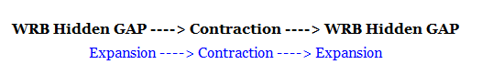

In addition, it’s highly recommend you use a data program that has **replay capabilities** or use a **screen recorder** to record your charts in real trading conditions so that you can use your replay/recording archives to develop a better intuition about the development of WRB Hidden GAPs and WRB Zones.

Simply, develop a habit of monitoring real time price action along with having archives of the real time price action via replay or screen recording because hindsight charts alone is a poor way to learn the price action of any trading method regardless if it’s yours or ours.

http://www.thestrategylab.com/images/BlueSphere.gif **Which of the above key market events are suitable for your particular trading instrument?**

It’s easy to determine which key market events have had an impact on the price action of your trading instrument. You only need to look for swing points and strong continuation price actions involved with key market events. In fact, it’s very common to see key market events in one country have an impact on the price action in another country because the world economies and markets are globally connected.

Therefore, if you see the price action of your trading instruments having big swing points and big strong continuation price action in relationship to specific types of key market events…keep your own personal database of those key market events and then put them in your own personal calendar to alert you when those key market events are scheduled for release again. Unfortunately, you can’t do this for breaking news key market events but you can still be alerted by your real-time news resources being used for breaking news especially if it’s a familiar type of breaking news that has had a strong impact on the price action of your trading instrument.

Therefore, it's **your responsibility** to determine which type of key market events is suitable for monitoring while you trade so that you can be better prepare to react whenever key changes in supply/demand or volatility occurs in whatever price action you’re trading.

Also, ignoring how your trading instrument reacts to key market events is one of the **worst mistakes** you’ll make in trading…it’s a newbie trader mistake or a losing trader mistake.

## **WRB** Analysis Tutorial Chapter 3

**http://thestrategylab.com/images/News4.gif Trade Signals or Pattern Signals as WRB Zones**

Tutorial chapter 3 is for traders that have a trade signal strategy. Simply, your own custom trade signals can be used as WRB Zones if they are involved (results) as a swing point or strong continuation price action as defined by the definitions from WRB Tutorial Chapter 2 without the key market event rule requirement. Further, the **difference between tutorial chapter 2 and 3** is that tutorial chapter 2 uses a “key market event” to trigger the price action definitions for a swing point or strong continuation price action. In contrast, tutorial chapter 3 uses a trade signal (not a key market event) to trigger the price action definitions for a swing point or strong continuation price action. Yet, if you do not have a trade signal strategy…you do not need to read/learn tutorial chapter 3. Also, if you do not have a trade signal strategy, you can freely use one of our trade strategies called Fading Volatility Breakouts (FVB) **@** <http://www.thestrategylab.com/tsl/forum/viewforum.php?f=89>

With that said, earlier in this study guide (page 11) we revealed to you a list of general strategies that traders are using with WRB Analysis. One particular method on the list was Japanese Candlestick patterns. Therefore, one particular Japanese candlestick pattern will be used as a tutorial chapter 3 example of **merging** candlestick patterns with WRB Analysis. Yet, as stated earlier in this free study guide, WRB Analysis is **not** based upon Japanese Candlestick Analysis. In contrast, WRB Analysis is based upon the combination of volatility analysis and supply/demand analysis…applicable to bar charts or candlestick charts.

To get started, you must learn that there are two sources of WRB Zones while using your own trade signal strategies or any of our trade signal strategies.

 **RANGE** is the price action between the highest high and lowest low of the intervals involved within your trade signal strategy.

 **WRB Hidden GAP (unfilled)** interval that occurs within the price action of your trade signal or the first WRB Hidden GAP that appears after your trade signal.

These types of WRB Zones requires less work because you don't need to be concerned with economic calendars, fed events nor real-time continuous news sources. In addition, you'll be faster at recognizing these types of WRB Zones in real-time due to the fact that you’re already familiar with your own pattern signals for those using their own custom strategies in comparison to using our trade strategies as WRB Zones.

As a reminder, we can setup a hidden private message thread (for your eyes only via request only) at the forum for you to post charts and ask questions as you integrate WRB Analysis into your trade strategies so that we can help you if you need help to determine your WRB Zone via your trade strategies.

**http://thestrategylab.com/images/News4.gif Swing Point Price Action** 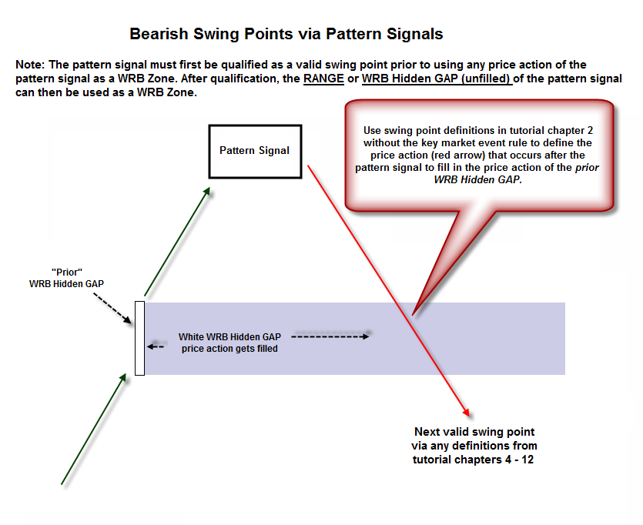

<http://www.thestrategylab.com/tsl/forum/download/file.php?id=523>

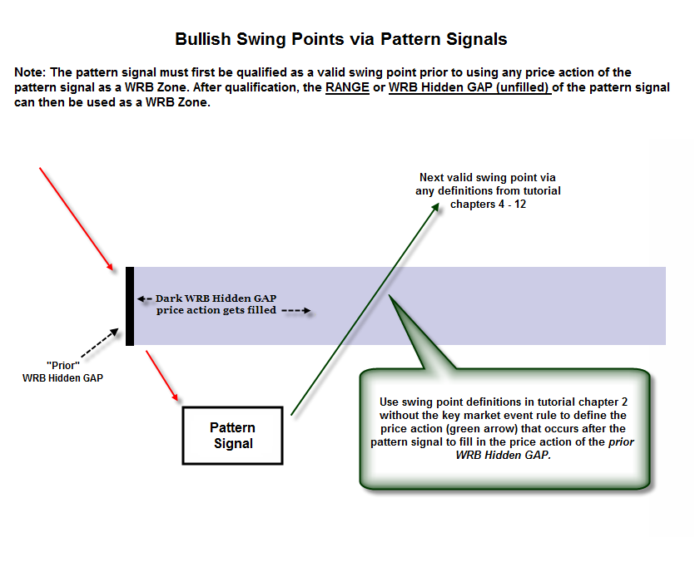

<http://www.thestrategylab.com/tsl/forum/download/file.php?id=524>

The above **generic swing point charts** are self explanatory and we’ll now use a basic Japanese Candlestick pattern signal called Bullish Engulfing as an example of using a pattern signal as a WRB Zone in tutorial chapter 3 because the generic engulfing candlestick pattern is something you’ll see in every typical Japanese Candlestick book or online article.

By the way, if you’re curious, the described Japanese Candlestick pattern that you’re **about to read** is not a trade signal from the trading reports AJCTR, APAOR, STR or VTR. Therefore, you must use your own trade strategies or our Fading Volatility Breakout trade strategy at the support forum to get proper support on how to use trade signals as WRB Zones. Simply, trade signals are more than just a signal for you to trade…sometimes they qualify as a WRB Zone to help with understanding the price action and to help with the trade management of trade signals that follow.

**Definition of the RANGE**

The **RANGE** is the price action between the highest high and lowest low of the intervals involved as your pattern signal (pretend the generic engulfing pattern is your trade signal) and we’ve added an additional price action rule to this generic engulfing candlestick pattern in that the Engulfing interval (c1) must engulf the close and open of a Doji interval (c2) and the only thing you care about the price action before c2 is that it’s declining. This is a very simple pattern signal prior to learning about WRB Analysis.

*Note: Intervals in the candlestick chart study guide version are annotated with* ***(c)****. In contrast, intervals in the bar chart study guide version are annotated with* ***(b)****. Thus, WRB Analysis is applicable the same on bar charts for those that don’t want to use candlestick charts. Yet, if you use candlestick charts, it does not imply you’re doing Japanese Candlestick Analysis.*

The chart below shows typical intervals (c1 and c2) involved in any bullish engulfing price action although c2 does not need to be a doji. The c2 can also be a dark (red) interval or white interval if they occur inside the body of the c1 interval for an engulfing price action.

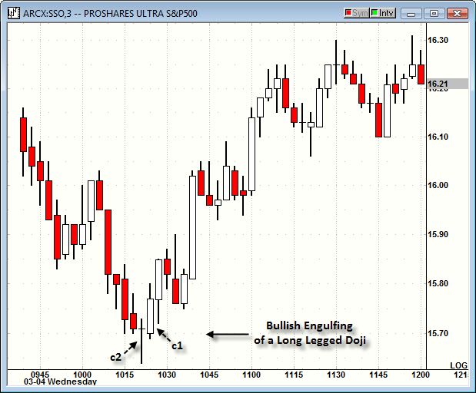

**Proshares SSO exchange traded funds**

The **RANGE**…can be different as shown below via several charts depending upon if you have a WRB interval as the c1 or c2 interval. The first chart below…there is no WRB interval as a c1 or c2. Thus, the range involves the price action between the High and Low of those two particular intervals.

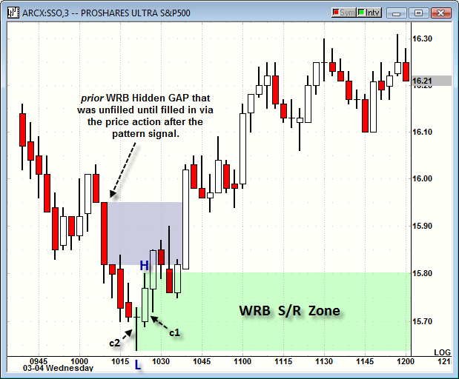

**Proshares SSO exchange traded funds**

In contrast to the above chart…the below chart has the c1 interval as a WRB. This changes the range because we must now include the three intervals before the WRB and they are shown as c2, c3 and c4 intervals on the chart. Therefore, the **RANGE** now involves the highest high and lowest low (annotated on charts as **H** and **L**) amongst all four intervals (c1, c2, c3 and c4).

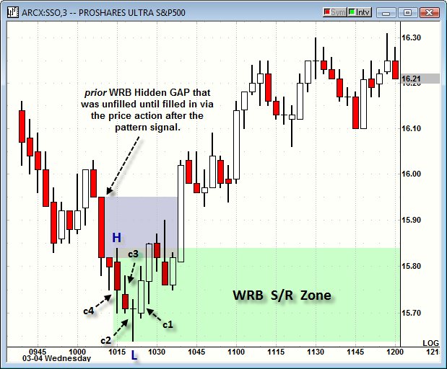

**Proshares SSO exchange traded funds**

**Definition of the WRB Hidden GAP (unfilled)**

**WRB Hidden GAP (unfilled)** involves two possibilities.

 WRB Hidden GAP (unfilled) interval that occurs within the price action as a c1 or c2 interval.

 **first** WRB Hidden GAP that appears after your trade signal.

Also, it’s possible for both to appear as explained further below. The chart below represents a WRB Hidden GAP (unfilled) interval that occurs within the price action as a c1 or c2 interval.

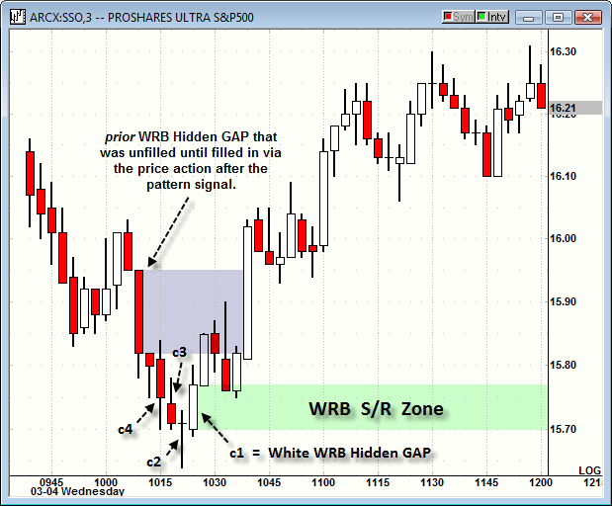

**Proshares SSO exchange traded funds**

In contrast, the chart below represents a first WRB Hidden GAP that appeared after the pattern signal.

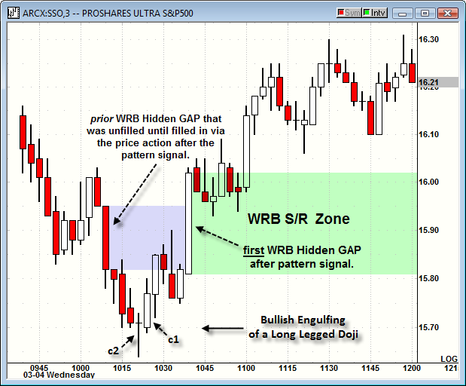

**Proshares SSO exchange traded funds**

Comparing the two most recent charts above that represents a WRB Hidden GAP (unfilled) that’s a c1 or c2 interval versus the first WRB Hidden GAP that occurs after your pattern signal…these are different types of WRB Zones if they qualify as a swing point or strong continuation price action.

Also, if you’re confused or curious about why we label the price action **c2 ---> c1** instead of **c1 ---> c2**…there’s an explanation at the TSL Support Forum @ <http://www.thestrategylab.com/tsl/forum/viewtopic.php?f=61&t=1195>

http://www.thestrategylab.com/images/BlueSphere.gif **What if both types of the WRB Hidden GAP (unfilled) are present?**

The WRB Hidden GAP (unfilled) within the price action of your pattern signal must be designated as the swing point whereas the first WRB Hidden GAP that occurs after your pattern signal is a continuation price action if both types of WRB Hidden GAP (unfilled) are present. Therefore, for the swing point identification, use the one that occurs within your pattern signal as the WRB Zone.

http://www.thestrategylab.com/images/BlueSphere.gif **What if the RANGE is too large of a WRB Zone?**

RANGE of your pattern signal will only be too large if you have not identified properly the key price actions of your pattern signal. That’s where we can help via the support you have available. Thus, ask for help if the RANGE is frequently too large.

Also, WRB Zones via RANGE have no reliability advantage over WRB Zones via WRB Hidden GAPs (unfilled). Yet, whichever you decide to use…be consistent so that you can properly document your trading plan and it’s the documentation that will give you valuable feedback to properly make an adjustments (adapting) your trade strategies to changes in the market environment.

http://www.thestrategylab.com/images/BlueSphere.gif **When is it Tradable?**

The above information reveals that your pattern signals are still useful regardless if you traded them or not because they can be used as WRB Zones in validating pattern signals that occurs afterwards if the pattern signals occurs within the WRB Zone of a prior pattern signal.

You only need **one tick from any of the intervals** in the price action of your pattern signal to occur within a WRB Zone to become valid for trading. Thus, any tick of a price from your pattern signal that shares a tick of a price within the WRB Zone…it’s a valid for trading.

The chart below is the actual (not altered) chart of Proshares SSO via using the entire RANGE of the c1 (WRB), c2, c3 and c4 intervals involved with the Bullish Engulfing price action.

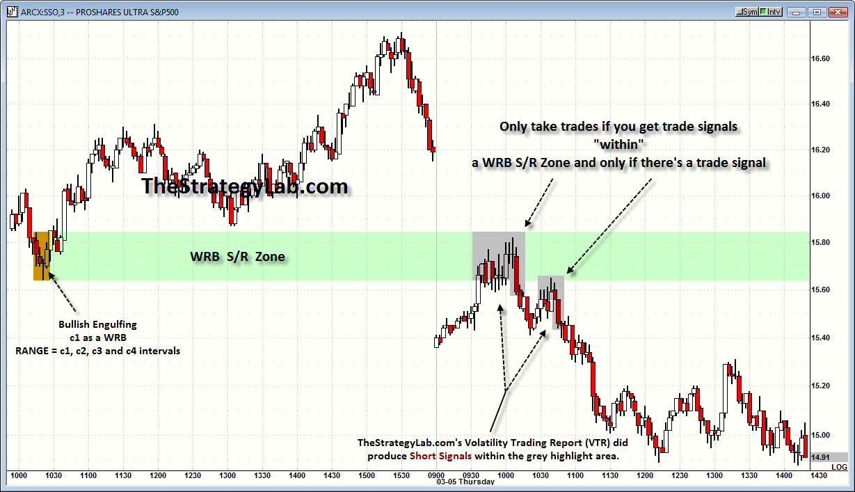

**Proshares SSO exchange traded funds @**<http://www.thestrategylab.com/tsl/forum/download/file.php?id=529>

You should also notice that the WRB Zone is unfilled which is the reason why the green highlight area continues to the right all the way to the end of the chart.

Simply, the **lifespan** of a WRB Zone involving pattern signals can be used again and again until it’s filled in regardless if you get other pattern signals that generate their own WRB Zones.

**http://thestrategylab.com/images/News4.gif Strong Continuation Price Action**

There are only two types of price actions as defined in tutorial chapter 2 as strong continuation and it’s highly recommended you review the tutorial chapter 2 definitions **prior** to learning additional price actions here in tutorial chapter 3 that’s specific towards particular trade strategies. Also, here in tutorial chapter 3 there’s another price action rule in addition to the rules for tutorial chapter 2 strong continuation #1 and #2 price actions. That additional rule is that the price action must occur **at/after a higher low (uptrend) or lower high (downtrend)** or within any price action you have already identified as directional (up or down) via your own price action definitions.

 **Definition #1** - This is a **breakout** interval via a WRB Hidden GAP (unfilled) interval above/below a prior reaction point and it’s only for traders that use a breakout strategy of a trendline, reaction high/low, swing point, range or volatility contraction price actions. The next WRB Hidden GAP that appears **after** the **WRB Hidden GAP (unfilled**) breakout interval will then become your “first WRB Hidden GAP” as a WRB Zone. Therefore, the additional rule involves the “first WRB Hidden GAP” having a higher low (uptrend) or lower high (downtrend) in comparison to the breakout interval.

 **Definition #2** - Expansion/Contraction/Expansion analysis via v2 WRB --> contracting intervals --> v1 WRB and at least one of the **v intervals** is a WRB Hidden GAP (unfilled). Further, if your trade signal (e.g. pin bar, flag, inside bar, harami) occurs within the contracting volatility before the v2 interval or as the v2 interval or within the contracting volatility between the v2 and v1 intervals…the v1 interval becomes your “first WRB Hidden” as a WRB Zone. Therefore, the additional rule involves a higher low (uptrend) or lower high (downtrend) between the v1 interval and your trade signal price action.

Once again, the higher low (uptrend) or lower high (downtrend) requirement does not exist for tutorial chapter 2 but it is a new rule requirement here in tutorial chapter 3 because this chapter is more trade signal specific to your own trade strategies.

http://www.thestrategylab.com/images/BlueSphere.gif **What to do if your trade signal is not involved with the above price action definitions?**

The support (answers to your questions) will resolve this problem and help you identify the key intervals involved in your trade signals to help identify key changes in supply/demand if the price action results as a swing point or strong continuation price action.

Therefore, as a reminder, we can setup a hidden private message thread (for your eyes only via request only) at the forum for you to post charts and ask questions as you integrate WRB Analysis into your trade strategies so that we can help you if you need help to determine your WRB Zone via your trade strategies.

## Trade Management and Trade Entry

**http://thestrategylab.com/images/News4.gif Initial Stop/Loss, First Stop Adjustment and Profit Targets**

Trade management after entry via your trade signals is arguably equally important as your entry signal method itself. Further, it’s recommended that concepts from the entry signal should be used as a component of the trade management after entry. Therefore, it’s recommended to use WRB Analysis as initial stop/loss protection, first stop adjustment and profit targets because they adapt extremely well to price action change in supply/demand, change in volatility, change in range and change in trend even if you have not merged WRB Analysis into your entry signal method.

**Why?**

Trade management via WRB Analysis **avoids the flaws** of traditional trade management rules that’s commonly discussed at other websites, forums, blogs, chat rooms and twitter as if price action never changes from one trade to the next trade or from one trading day to the next trading day. Simply, if you’re using the same risk:reward ratios every trading day as if changes doesn’t occur in supply/demand, volatility, range or trend…you’re managing your trades at a disadvantage.

With that said, the discussion below is in reverse order involving the components of trade management because most traders have the most problems with the component called **profit targets (reward)**. There are **basic** and **advance** profit target strategies via WRB Analysis and you can use them in any combination. In contrast, fixed number profit targets (e.g. exit @ 1.5 points) and risk:reward profit targets (e.g. risk 1 point for a 2 point reward) are flawed because they **assume in error** that the price actions you’re trading are the same from one trade to the next trade or that every trading day is the same.

The profit target strategies discussed in this document are only the **basic** variations. In contrast, fee-base clients of the WRB Analysis Tutorial Chapters 4 – 12 or trade signal strategies have free access to the **advance** profit target strategies via WRB Analysis. Thus, the advance profit targets are not discussed in this tutorial document and are only posted at the fee-base client’s private forum.

**Profit target 1 (pt1)** is your primary profit target regardless if it’s via the basic or advance type because it’s at pt1 where you must use WRB Analysis to determine if you should exit the entire position, scale out the position or keep the entire position for an bigger profit target (pt2, pt3, pt4 et cetera). Profit targets beyond pt1 are only discussed with fee-base clients of the WRB Analysis Tutorials 4 – 12 or fee-base clients of our trade signal strategies (FVB, DCM, AJCTR, APAOR, STR and VTR) @ <http://www.thestrategylab.com/TradingReports.htm>

Regardless, you must do backtesting along with using information from your real trading results to determine if your trade signals tend to reach a pt1, pt2, pt3 or higher especially in different volatility market conditions (low volatility versus high volatility versus normal volatility). For example, if you trade strategies **tend** to reach a pt2 as verified by your actual trade statistics (not backtesting results)…you’ll know your reward profit target the next time your trade signal appears and you’ll be using a profit target that’s **adaptive** to current price action instead of a fixed number profit target.

**http://thestrategylab.com/BlueBox.gifBasic Profit Targets after Long Entry**

*Example - pt1 price @ 701 < pt2 price @ 705 < pt3 price @ 710*

You have several choices of basic profit targets to choose from the below price actions.

http://thestrategylab.com/OrangeBullet.gif The first WRB as a Close > Open interval (don't wait for the interval to complete itself) that appears ***after and above*** the pattern signal. This can’t be shown via a hindsight chart (another flaw via learning via hindsight charts) but soon I’ll provide a direct link to real-time video.

For example, pretend you’re using the 15 min chart interval (not the below chart) and you enter a trade @ 1045am. The trade becomes profitable and develops into a Close > Open WRB interval @ 1053am via a volatility spike that’s **prior** to the next 15 min interval completing @ 1100am. You would exit your trade position @ 1053am while the interval is still a Close > Open WRB even though it’s not 1100am (completion of the interval).

http://thestrategylab.com/OrangeBullet.gif WRB Hidden GAP (Close > Open) upon close of the interval that appears ***after and above*** the pattern signal.

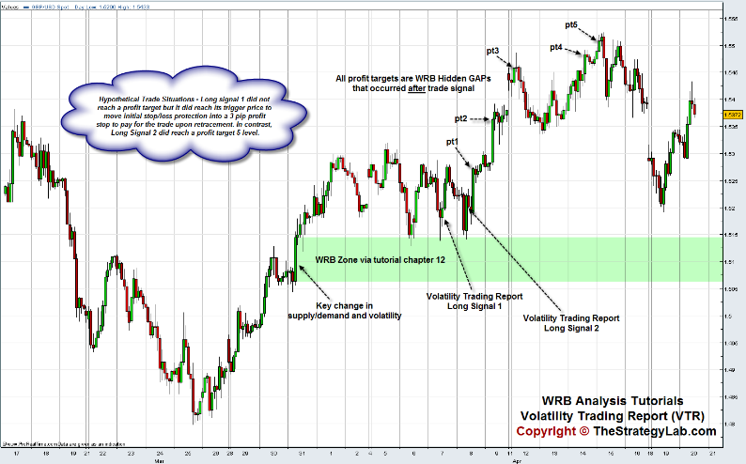

**Forex GBP/USD currency @** <http://www.thestrategylab.com/tsl/forum/download/file.php?id=540>

http://thestrategylab.com/OrangeBullet.gif WRB Zones that are still open (not filled in by the price action) and ***above*** the pattern signal.

**http://thestrategylab.com/BlueBox.gifBasic Profit Targets after Short Entry**

*Example - pt1 price @ 701 > pt2 price @ 662 > pt3 price @ 628*

You have several choices of basic profit targets to choose from the below price actions.

http://thestrategylab.com/OrangeBullet.gif The first WRB as an Open > Close interval (don't wait for the interval to complete itself) that appears ***after and below*** the pattern signal. This can’t be shown via a hindsight chart (another flaw via learning via hindsight charts) but soon I’ll provide a direct link to real-time video.

For example, pretend you’re using the 15 min chart interval (not the below chart) and you enter a trade @ 1045am. The trade becomes profitable and develops into an Open > Close WRB interval @ 1053am via a volatility spike that’s **prior** to the next 15 min interval completing @ 1100am. You would exit your trade position @ 1053am while the interval is still an Open > Close WRB even though it’s not 1100am (completion of the interval).

http://thestrategylab.com/OrangeBullet.gif WRB Hidden GAP (Open > Open) upon close of the interval that appears ***after and below*** the pattern signal.

http://thestrategylab.com/OrangeBullet.gif WRB Zones that are still open (not filled in by the price action) and ***below*** the pattern signal.

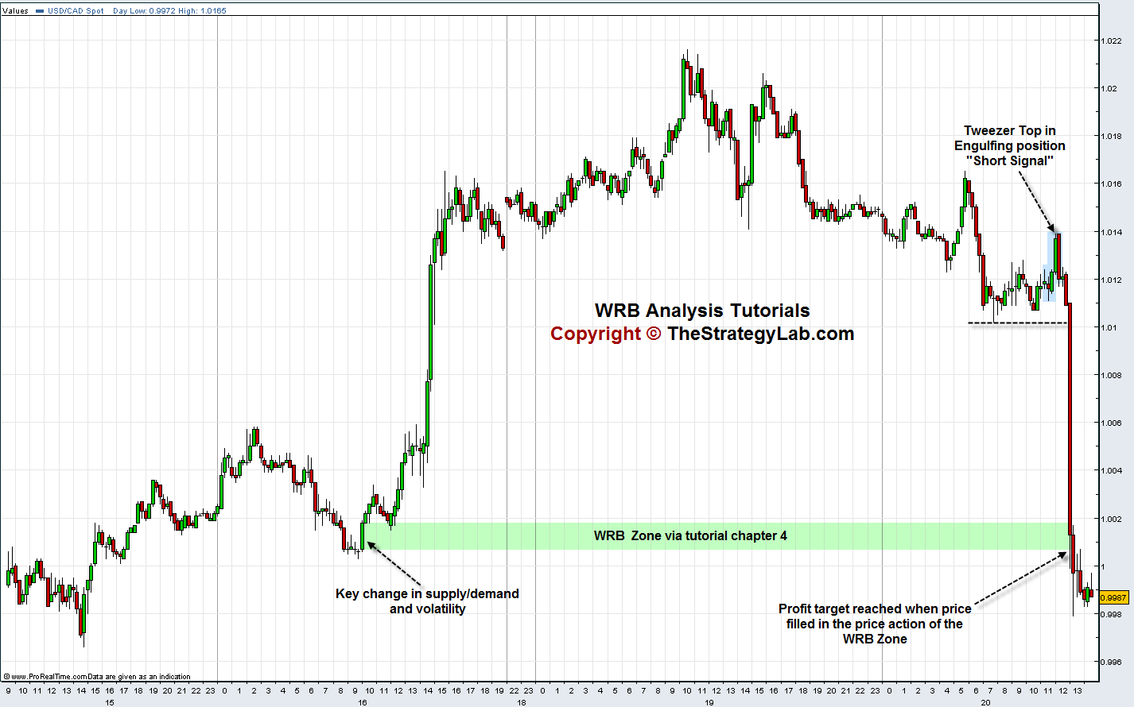

**Forex USD/CAD currency @** <http://www.thestrategylab.com/tsl/forum/download/file.php?id=539>

**http://thestrategylab.com/BlueBox.gifBasic First Stop Adjustment**

You should move your initial stop/loss protection into a 1 to 3 tick/pip profitable trailing stop or whatever the first stop adjustment is needed to **pay for the trade** (commission or spread) instead of using a breakeven first trailing stop adjustment because breakeven is actually a trade loss after you factor in the **cost of the trade**. Yet, do not move your initial stop/loss protection into a profitable trailing stop until a **trigger price** is reached.

You have **three choices to use as a trigger price** to tell you it’s time to move your initial stop/loss protection into a profitable trailing stop. Also, the below recommendations are trade signal price actions regardless to your actual trade entry price.

http://thestrategylab.com/OrangeBullet.gif The trigger price is the formation of a **WRB** that that has its close ***after and below*** your Short signal price or that has its close ***after and above*** your Long signal price. Yet, do not wait for the interval to complete itself as a WRB because sometimes it may not be a WRB when the interval completes…retracing back upwards to turn a profitable trade into a losing trade when it hits your initial stop/loss protection.

For example of using the WRB to trigger stop adjustment in a Short position, pretend you’re using the 15 min chart interval and you enter a trade @ 1045am. The price action declines and a WRB forms @ 1053am via a volatility spike that’s **prior** to the next 15 min interval completing @ 1100am. You would then adjust your initial stop/loss protection into a profitable trailing stop @ 1053am even though the interval has not completed itself @ 1100am.

http://thestrategylab.com/OrangeBullet.gif The trigger price is the formation of a **WRB Hidden GAP** that closes (interval completes) as a WRB Hidden GAP below your Short signal price or as a WRB Hidden GAP above your Long signal price.

http://thestrategylab.com/OrangeBullet.gif The trigger price is a **fixed price** that occurs below your Short signal price or above your Long signal price (e.g. moves 7 ticks/pips in the profit).

The flaw with using fixed trigger prices or fixed profit targets is that they often are not in sync with the current price action because they are designed like a risk:reward scenario by assuming in error the price action will be the same each time after entry. In contrast, trade management after entry via WRB Analysis, are **adaptive** to current price action after entry.

By the way, your trade signals will have different results when occurring in low or declining volatility market conditions versus high or rising volatility market conditions. Simply, you’ll need to use **different trigger prices and profit targets as volatility changes** to minimize early exits. This is something we work with **fee-base clients** whenever they request help with such involving exploiting the **adaptive** aspect of WRB Analysis to improve the performance of their profitable trades. In addition, we only share with fee-base clients trailing stop placement when a profitable trade continues and develops into a trend or strong continuation price action.

**http://thestrategylab.com/BlueBox.gifInitial Stop/Loss Management**

To encourage you to see how WRB Analysis will improve the performance of your trade signals or the performance of our own trade signals…we’re only willing to discuss the initial stop/loss protection at our TSL Support Forum within the **free** trade signal strategy called **Fading Volatility Breakout (FVB)**.

To gain free access to the FVB trade strategy and the **initial stop/loss protection** rules via WRB Analysis, you must follow the instructions **@** <http://www.thestrategylab.com/tsl/forum/viewtopic.php?f=89&t=533>

The free strategy and initial stop/loss protection will allow you to see how to merge WRB Analysis into the trade management of any trade signal strategy you may be using regardless if you’re trading within trends, ranges and volatility or key changes in supply/demand.

In addition, there’s advance trade management information and **real-time support** about **adjusting profitable trailing stop**…when and where to place them to protect the bulk of the profits as a profitable trade becomes more profitable after the first stop adjustment involving one contract/lot traders or multiple contracts/lots traders. Yet, the advance information with real-time support are only provided to fee-base clients of the WRB Analysis Tutorials 4 – 12 and fee-base clients of our trade signal strategies (FVB, DCM, AJCTR, APAOR, STR, VTR) **@** <http://www.thestrategylab.com/TradingReports.htm>

**http://thestrategylab.com/BlueBox.gifAccolades (Testimonials)**

*“I trade Forex, using hourly, daily, weekly charts. I’ve got a few questions if you don’t mind. I purchased the WRB Chapters 1 – 3 + adv. Chapter 4 end of December…It has improved my trading and price action understanding.”*

[](http://www.thestrategylab.com/images/033012-Accolade.png) [read entire context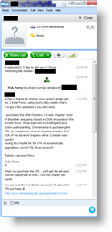](http://www.thestrategylab.com/images/033012-Accolade.png)

**We’ve posted below several of our favorite accolades from among +1815 comments (testimonials) that been sent to us by our fee-base clients and by traders we've freely helped that have a sincere interest in our trade methodology and you can read them @** <http://www.thestrategylab.com/Accolades.htm>

**Hopefully the information (testimonials) posted will help those traders having difficulty via search engines or forum discussions to find out the opinions or experiences from those using our methods because of our strict** [copyright protection](http://www.thestrategylab.com/CopyrightProtected.htm) **and** [anti-spam](http://www.thestrategylab.com/AntiSpamPolicy.htm) **policies involving TheStrategyLab.com**

## **WRB** Analysis Tutorial Chapters 4 - 12

**http://thestrategylab.com/images/News4.gif Advance WRB Analysis and Zones**

You now have learned and applied tutorial chapters 1, 2 and 3 that represent the basic tutorial chapters **prior** to learning/applying the Advance WRB Analysis Tutorial Chapters 4 – 12 education materials.

|  |
| --- |
|  |

[](https://www.paypal.com/cgi-bin/webscr?cmd=_s-xclick&hosted_button_id=TSDDMT68MFDAY)[**Advance WRB Analysis Tutorial Chapter 4**](http://www.thestrategylab.com/WRBAnalysisTutorials.htm) - Your payment of **$15.33** (savings of $11) will give you access only to advance tutorial chapters 4. The advance tutorial chapter 4 will strengthen your understanding of price actions involving WRB Hidden GAPs that identify when key market participants are buying or selling their positions resulting as **volatility breakouts**...producing swing points and strong continuation price actions. Further, the advance tutorial chapter 4 **does not** involve key market events to give market context. In contrast, it involves **advance** price action analysis to give market context.   
  
 Access to the private WRB forum   
 Basic Tutorial Chapters 1 – 3   
 FVB Basic Trade Signal Strategy  
 Advance Tutorial Chapter 4   
 Advance WRB Analysis Trade Management File  
 Your own private thread for you to get support in merging WRB Analysis into your current trade methodology

**[](https://www.paypal.com/cgi-bin/webscr?cmd=_s-xclick&hosted_button_id=HEC7NYAJZKJBY)**[**Advance WRB Analysis Tutorial Chapters 4 - 12**](http://www.thestrategylab.com/WRBAnalysisTutorials.htm) - Your payment of **$237** will give you access to different types of WRB Zones that are suitable for different types of price actions that will allow you to adapt more easily when market conditions changes. In addition, you'll have more choices of WRB Zones to determine which is compatible with your trade method or trading style.

 Access to the private WRB forum   
 Basic Tutorial Chapters 1 – 3   
 FVB Advance Trade Signal Strategy in combo with FVB Basic Trade Signal Strategy  
 Advance Tutorial Chapters 4 - 12   
 **(new)** Directional Creeper Movement (DCM) Analysis and Trade Signal Strategy

 **(new)** ##WRB_Analysis real-time chat room   
 Bonus Trade Signal Strategies associated with tutorial chapters 11 & 12 (via request only)  
 Advance WRB Analysis Trade Management File  
 Your own private thread for you to get support in merging WRB Analysis into your current trade methodology

The new **Directional Creeper Movement (DCM) Analysis** and **Directional Creeper Movement (DCM) Trade Signal Strategy** helps trading in price actions like the **current** low volatility market conditions and helps prevent trading against the trend (up or down). In addition, the Creeper Movement is currently being used by me actively in the free **##TheStrategyLab chat room** and about 50% of my trades are via the Creeper Movement Analysis. Simply, you can watch in **real-time** how I use WRB Analysis merged with a trade signal strategy to help you determine the merits of purchasing the advance tutorial chapters 4 - 12. #TheStrategyLab chat room log-in instructions **@** [viewforum.php?f=164](http://www.thestrategylab.com/tsl/forum/viewforum.php?f=164) (objective details of the strategy only discussed with fee-base clients that have purchased the advance tutorial chapters 4 - 12 package).

If the above payment links do not work…please use the direct payment info via **TheStrategyLab.com website @** [WRBAnalysisTutorials.htm](http://www.thestrategylab.com/WRBAnalysisTutorials.htm)

[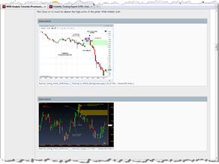](http://www.thestrategylab.com/images/wrb-analysis-advance-tutorial-chapter-4-excerpt-2.png)Click on the below images to view examples of the private WRB forum and advance tutorial chapter 4 excerpts.

[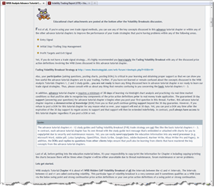](http://www.thestrategylab.com/images/wrb-analysis-advance-tutorial-chapter-4-excerpt-1.png)[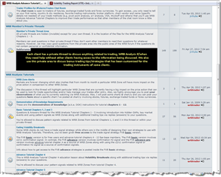](http://www.thestrategylab.com/images/wrb-analysis-advance-tutorial-chapter-4-forum-example.png)

To learn more about the benefits of the advance tutorial chapters 4 – 12 and its associated trade signal strategies…you can post your questions **@** [viewforum.php?f=5](http://www.thestrategylab.com/tsl/forum/viewforum.php?f=5)

## **D**emonstration of Knowledge (a.k.a. DOK)

First of all, you must learn/apply basic tutorial chapters 1 - 3 for a minimum of **10 trading days** prior to attempting to merge it with your trade strategies. It’s after these initial 10 days that you can began posting a **“demonstration of knowledge”** (DOK) to show us that you’ve learned and understand the tutorial chapters. Also, your posted DOK will extend your free 30 day support into another free 30 day support as a free user…allowing you to better determine the merits of the WRB Analysis Tutorials.

*Note: Free 30 day support is only allowed to be extended one time at the TSL Support Forum.*

The **DOK** allows us to provide better support to you and others if we see WRB Analysis problems in your charts or commentary along with showing to us if you’re ready to proceed to the next tutorial chapter. In addition, other traders will be able to learn and benefit from your DOKs. Yet, if you’re uncomfortable in letting others read your messages, we can easily create a private thread at the TSL Support Forum for you to post questions and DOKs in private so that other users cannot read your messages. In fact, if the TSL Support Forum seems inactive…it is not. There are a **few users** **actively posting questions and DOKs** within their own **private thread** every month. Therefore, if you want a **private thread** to use for your free 30 day support and/or DOKs…please do not hesitate to **contact us** via private message **@** <http://www.thestrategylab.com/tsl/forum/ucp.php?i=pm&mode=compose&u=2>

In fact, about **10% of the users** that download this free study guide eventually do contact us to setup a private thread for their free 30 day support.

With that said, **we do not take questions about WRB Analysis Tutorials via email** from traders that have access to this study guide to encourage you to use the discussion forum and using the forum helps to ensure that all WRB Analysis Tutorial members are learning from each other besides from TheStrategyLab.com

More information about the “demonstration of knowledge” (D.O.K) **@**

<http://www.thestrategylab.com/tsl/forum/viewforum.php?f=61>

## **W**RB Analysis Tutorials Updates

The markets are forever changing and that implies we need to adapt (make changes to the WRB Analysis) whenever necessary to maintain the understanding of the price action.

Therefore, there will always be updates to the WRB Analysis Tutorials due to changing market conditions, corrections, or clarifications…you’ll find it at the forum in the thread titled **Updates and Announcements for Basic Tutorial Chapters 1 – 3 @** <http://www.thestrategylab.com/tsl/forum/viewtopic.php?f=61&t=1005>

Further, it’s **your responsibility** to review the updates thread at least once per month to be up to date with any new information or clarifications to the WRB Analysis Tutorial Chapters 1 – 3 study guide.



Also, you’ll notice that the charts in this file that have been re-sized to fit in this word document. In such cases, I’ve included a direct link below the charts to the actual size charts located at the forum that have not been re-sized for you to download/print to be saved with this document…you should put it in a binder folder.

## **C**opyright and Legal Stuff

**http://www.thestrategylab.com/CopyRight.gifT**he**S**trategy**L**ab.com and M.A. Perry (a.k.a. wrbtrader and NihabaAshi) WRB Analysis and Price Action Only strategies are protected under **The Digital Millennium Copyright Act**.

Copyright © 2000 **T**he**S**trategy**L**ab.com

Therefore, you yourself are not allowed to re-disseminate, re-distribute, repost any aspects of our price action only strategies, wrb analysis or any other resources of ours to file sharing, message boards, forums, blogs, websites, youtube, myspace, facebook, twitter, news groups, emails, mail nor via any other social network communication source without the permission of **TheStrategyLab.com** regardless if you're a fee-base client or not. In addition, you’re not allowed to make a copy and then share or sell that copy nor are you allowed to share or sell the original while keeping a copy without the permission of TheStrategyLab.com

You have our permission to give traders a copy of the WRB Analysis Tutorial Chapters 1, 2 and 3 free study guide. It's the only information from our free or fee-base services you're allowed to share with other traders. However, you're not allowed to share the advance tutorial chapters 4 - 12, trade signal strategies nor any other education material of TheStrategyLab.com  
  
Further, you're not allowed to provide education (free or fee-base) via revealing concepts from our WRB Analysis Tutorials or Trade Signal Strategies regardless if you use the exact same words or rephrase the concepts without the permission of TheStrategyLab.com and members that ignore the copyright protection...the following will occur:

 You will be denied access to corrections, denied access to updates and new versions, denied access to the TSL Support forum itself, not allowed to purchase any other fee-base resource of TheStrategyLab.com (e.g. FVB advance trade signal strategies, DCM trade signal strategy, AJCTR trade signal strategies, APAOR trade signal strategies, STR trade signal strategies, VTR trade signal strategies, Advance WRB Tutorial Chapters) and not allowed access to the **mentor/student list** for **in person** mentoring.

 Agreements for your access to any new resources, bonus materials via special promotions and refund policy will be voided.  
  
 Forums, blogs, chat room or any other online location that continues to store the message posts or files after we've contacted them about the copyright protection violation will have the urls (links) to those messages removed from all major search engines cache (e.g. [Google DMCA policy](http://www.google.com/dmca.html)) upon notification to the search engines about the copyright protection violation.

Simply, **you're not anonymous.** TheStrategyLab.com and a few trusted clients are members of most active trading forums around the world via different user names. We often use their help and search engines to search for discussions involving concepts from our trade methodology.

Therefore, it's not worth risking losing access to resources of TheStrategyLab.com because we often give members in good standing free access to **bonus education material**.

Also, **each trader has a unique copy via an identifier code** embedded within the strategies to make it very easy for us to determine which client or none client has been sharing our fee-base material without our permission...including bogus (fake) copies. Therefore, we'll seek legal counseling for possible legal action against the member and any forum, blog, chat room, website et cetera that continues to allow posting or file storage of our copyright protected education material after search engines have removed the urls (links) from their cache.

WRB Analysis (wide range body analysis or wide range bar analysis) was designed in the early 1980's by M.A. Perry via merging the study of changes in volatility and supply/demand as a method for *understanding the price action*. This method has objective rules unique to TheStrategyLab.com and we have **traders documented since the 1980's** using our WRB Analysis although marketing of the trade methodology for financial compensation didn't occur until year 2000. In fact, WRB Analysis Tutorials is basically unchanged since origination except for some small adaptation in a few of the tutorial chapters whenever market conditions change to merit such a change. However, all changes are only via concepts of M.A. Perry from many years of market/trading experience.

With that said, you’re allowed to mention to any trader that you use **M.A. Perry WRB Analysis** or mention you’re using the trade signal strategies (FVB, DCM, AJCTR, APAOR, STR or VTR) from TheStrategyLab. Yet, if the individual requests more details from you about the concepts in the WRB Analysis Tutorials or trade signal strategies…send him/her to the TSL Support Forum or tell the trader to contact me directly via email.

Also, if you want to be financially compensated or want free access to our fee-base resources for sending traders to TheStrategyLab.com, contact me and request a referral code so that you can give to other traders because we have a few clients making consistent money from referrals via using their youtube, myspace, facebook or twitter social network when talking to others.

<http://www.thestrategylab.com/ReferralProgram.htm>

**Copyright** © **2000 TheStrategyLab.com**

Sincerely,  
M.A. Perry and Associates  
**T**he**S**trategy**L**ab.com

<http://www.thestrategylab.com/CopyrightProtected.htm>

*If a man does not keep pace with his companions, perhaps it is because he hears a different drummer. Let him step to the music he hears, however measured or far away*.--Henry David Thoreau